# CFD Simulation for Condensation on Horizontal Tubes

## 1. Introduction

This document details the comparative analysis of condensation over horizontal tubes simulated in ANSYS Fluent. The study involves:

2. Detailed comparative study including:  
 - Lee Model vs. Rattner and Garimella (Rattner, 2013) (Kleiner, 2019)  
 - Eccentricity effects (E = 0.2, 0.4, 0.6, 0.8) for refrigerants R32a, R134a, R410a  
  
This report provides comprehensive documentation of models and methods used during the simulations.

## 2. Models Used in Simulation

### 2.1 Multiphase Model: Volume of Fluid (VOF) (Yuan, 2012) (ANSYS, n.d.)

The Volume of Fluid (VOF) model is employed to simulate multiphase flow with a distinct interface between phases. This method is particularly effective for capturing the interface between liquid and vapor during condensation.  
  
Governing Equations:  
  
• The volume fraction equation:  
   
The tracking of the interface(s) between the phases is accomplished by the solution of a continuity equation for the volume fraction of one (or more) of the phases. For the $q^{\text{th }}$ phase, this equation has the following form:

$$\frac{1}{ρ_{q}}\left[\frac{∂}{∂t}\left(α_{q}ρ_{q}\right)+∇⋅\left(α_{q}ρ_{q}{\vec{v}}_{q}\right)=S_{α_{q}}+\sum_{p=1}^{n}{ } \left({\overset{˙}{m}}_{pq}-{\overset{˙}{m}}_{qp}\right)\right]$$

$$α_{q} : volume fraction for phase q$$

$${\overset{˙}{m}}_{pq} : mass transfer from phase q to phase p and vice versa$$

$$S_{α_{q}} : mass source term$$

The volume fraction equation will not be solved for the primary phase; the primary-phase volume fraction will be computed based on the following constraint:

$$\sum_{q=1}^{n}{ }α_{q}=1$$

The volume fraction equation may be solved either through implicit or explicit time discretization.

The Implicit Scheme which is used in this study is:

$$\frac{α_{q}^{n+1}ρ_{q}^{n+1}-α_{q}^{n}ρ_{q}^{n}}{Δt}V+\sum_{f}{ }\left(ρ_{q}^{n+1}U_{f}^{n+1}α_{q,f}^{n+1}\right)=\left[S_{α_{q}}+\sum_{p=1}^{n}{ } \left({\overset{˙}{m}}_{pq}-{\overset{˙}{m}}_{qp}\right)\right]V$$

$$n+1 :index for new time step \\ n :index for the current time step \\ α_{q,f}^{n+1}:face value for the{ q}^{\text{th }} volume fraction$$

$$V:volume of the cell$$

$$U_{f} volume flux through the face$$

• Material properties:

The density in each cell is given by:

$$ρ=α_{2}ρ_{2}+\left(1-α_{2}\right)ρ_{1}$$

• Momentum Equation:

A single momentum equation is solved throughout the domain, and the resulting velocity field is shared among the phases. The momentum equation, shown below, is dependent on the volume fractions of all phases through the properties $ρ$ and $μ$.

$$\frac{∂}{∂t}(ρ\vec{v})+∇⋅(ρ\vec{v}\vec{v})=-∇p+∇⋅\left[μ\left(∇\vec{v}+∇{\vec{v}}^{T}\right)\right]+ρ\vec{g}+\vec{F}$$

• Energy Equation:

The energy equation, also shared among the phases, is shown below.

$$\frac{∂}{∂t}(ρE)+∇⋅(\vec{v}(ρE+p))=∇⋅\left(k_{eff}∇T\right)+S_{h}$$

The VOF model treats energy, $E$, and temperature, $T$, as mass-averaged variables:

$$E=\frac{\sum_{q=1}^{n}{ } α_{q}ρ_{q}E_{q}}{\sum_{q=1}^{n}{ } α_{q}ρ_{q}}$$

where $E_{q}$ for each phase is based on the specific heat of that phase and the shared temperature.  
The properties $ρ$ and $k_{\text{eff }}$ (effective thermal conductivity) are shared by the phases. The source term, $S_{h}$, contains contributions from radiation, as well as any other volumetric heat sources.

• Surface Tension: continuum surface force (CSF) model

Surface tension arises as a result of attractive forces between molecules in a fluid. The addition of surface tension to the VOF calculation results in a source term in the momentum equation. the pressure drop across the surface depends upon the surface tension coefficient $, σ$, and the surface curvature as measured by two radii in orthogonal directions, $R_{1}$ and $R_{2}$

$$P_{2}-P_{1}=σ\left(\frac{1}{R_{1}}+\frac{1}{R_{2}}\right) \\ P_{1}and P_{2}are the pressure on the either side of the interface$$

The surface curvature is computed from local gradients in the surface normal at the interface. Let $n$ be the surface normal, defined as the gradient of $α_{q},$ the volume fraction of the $q^{th}$ phase.

$$n= ∇α$$

The curvature, $κ$, is defined in terms of the divergence of the unit normal, $\hat{n}$

$$κ=∇.\hat{n}$$

$$\hat{n}=\frac{n}{|n|}$$

The surface tension can be written in terms of the pressure jump across the surface. The force at the surface can be expressed as a volume force using the divergence theorem. It is this volume force that is the source term which is added to the momentum equation. It has the following form:

$$F_{\text{vol }}=\sum_{\text{pairs }}^{ij,i<j}{ }σ_{ij}\frac{α_{i}ρ_{i}κ_{j}∇α_{j}+α_{j}ρ_{j}κ_{i}∇α_{i}}{\frac{1}{2}\left(ρ_{i}+ρ_{j}\right)}$$

This expression allows for a smooth superposition of forces near cells where more than two phases are present. If only two phases are present in a cell, then $κ_{i}=-κ_{j}$ and $∇α_{i}=-∇α_{j}$, and Equation simplifies to:

$$F_{vol}=σ_{ij}\frac{ρκ_{i}∇α_{i}}{\frac{1}{2}\left(ρ_{i}+ρ_{j}\right)}$$

• Wall adhesion

the contact angle that the fluid is assumed to make with the wall is used to adjust the surface normal in cells near the wall. This so-called dynamic boundary condition results in the adjustment of the curvature of the surface near the wall.

If $θ_{w}$ is the contact angle at the wall, then the surface normal at the live cell next to the wall is

$$\hat{n} = {\hat{n}}_{w} cos⁡(θ_{w}) +{\hat{n}}_{w} sin(θ_{w})$$

$${\hat{n}}_{w} and {\hat{n}}_{w} are the unit vectors normal and tangential to the wall respectively.$$

### 2.2 Phase Change Models

#### 2.2.1 Lee Model (Zheng Liu, 2023)

The Lee model is a phase change model used to simulate the transition between liquid and vapor phases. It calculates the mass transfer rate based on temperature differences and latent heat of vaporization.  
  
Governing Equation: $${\overset{˙}{M}}_{v}=-{\overset{˙}{M}}_{l}=r_{e}α_{l}ρ_{l}\frac{T-T_{sat}}{T_{sat}},T≥T_{sat}$$

$${\overset{˙}{M}}_{l}=-{\overset{˙}{M}}_{v}=r_{c}α_{v}ρ_{v}\frac{T_{sat}-T}{T_{sat}},T<T_{sat}$$ where:

$$r_{e}and r_{c}are the mass transfer intensity factors$$

$$r_{c}=r_{e}*\frac{ρ_{l}}{ρ_{v}}$$

$$the default value for r_{e}is 0.1 which is used in the current study$$

#### 2.2.2 Paper model (Kleiner, 2019) (Rattner, 2013)

$$\overset{˙}{m}=\frac{{\overset{˙}{q}}^{*}}{Δh}=α_{v}\frac{ρ_{v}c_{p_{v} }\left(T-T_{sat}\right)}{Δt}\frac{1}{Δh}$$

$$∆h=h_{v}-h_{l}$$

## 3. Comparative Analysis

### 3.1 Lee Model vs. Paper Model

In this model ellipse geometry is used with eccentricity = $0.82$

#### 3.1.1Contours of the two models

|  |  |
| --- | --- |
|  |  |
|  |  |

#### 3.1.2Comparison Between Theory and the Two models

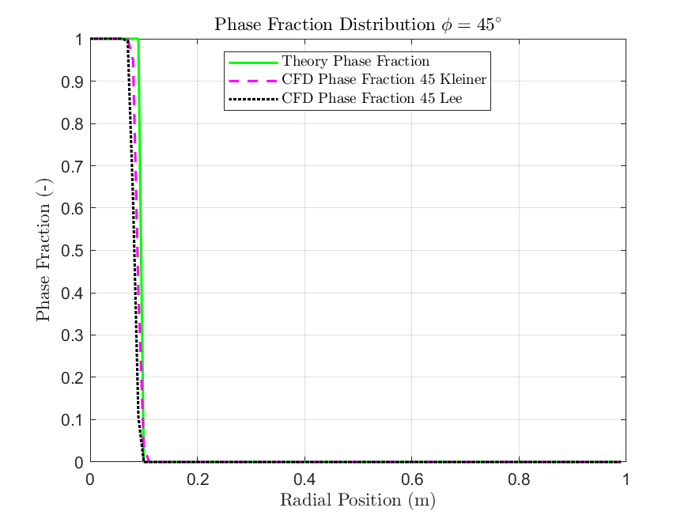

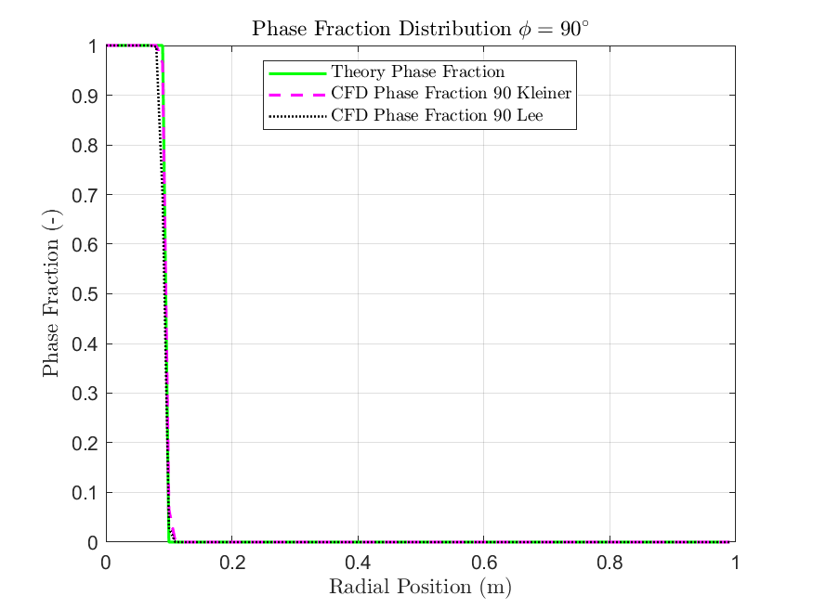

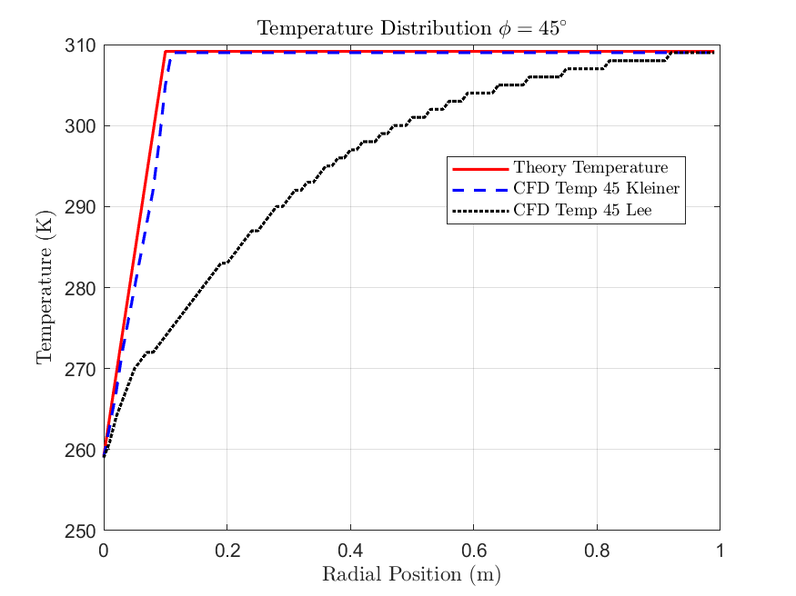

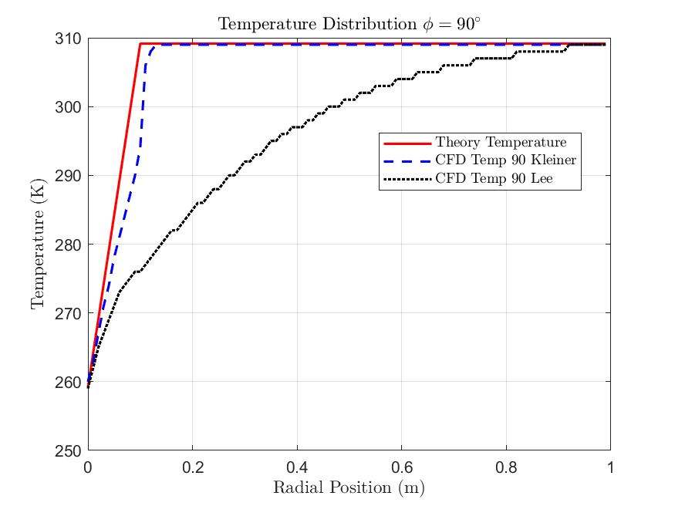

### 3.2 Eccentricity Effects for Refrigerants

• Eccentricity Values: E = 0.2, 0.4, 0.6, 0.8 $Eccintricity=\frac{b}{a}$

|  |  |  |  |  |
| --- | --- | --- | --- | --- |
| E | 0.2 | 0.4 | 0.6 | 0.8 |
| a (major axis) | 47.625 | 23.8125 | 15.857 | 11.90625 |
| b( minor axis) | 9.525 | 9.525 | 9.525 | 9.525 |

• Materials Tested: R32a, R134a, R410a

#### R32a Material (toolbox, n.d.) (Tian, 2020)

|  |  |  |  |
| --- | --- | --- | --- |
| Property | R134-a Liquid | R134-a Vapor | Unit |
| Density | 1240 | 13.6 | $$kg/m^{3}$$ |
| Dynamic Viscosity | 0.00031 | 1.1e-5 | kg/ (m s) |
| Molecular weight | 52.02389 | 52.02389 | $$kg/kmol$$ |
| Specific heat | 1900 | Piecewise-polynomial | $$j/(kgk)$$ |
| Standard state enthalpy | -4.265e+08 | -1.932e+08 | $$J/kgmol$$ |
| Thermal conductivity | 0.105 | 0.0105 | $$W/(mk)$$ |

E = 0.8

Temperature

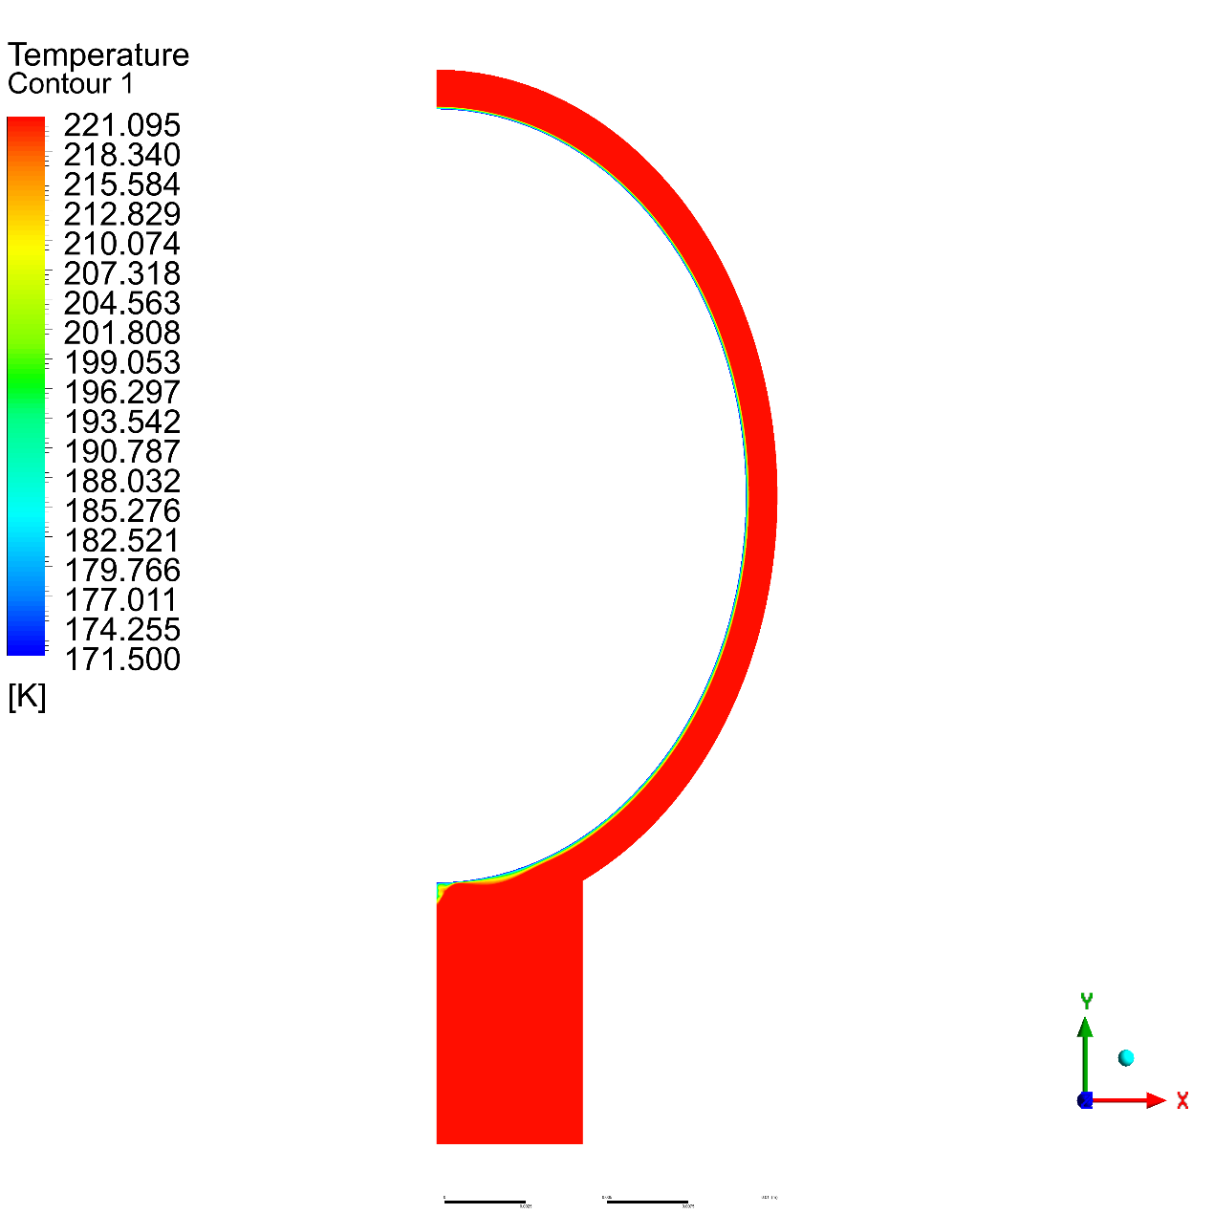

Volume Fraction

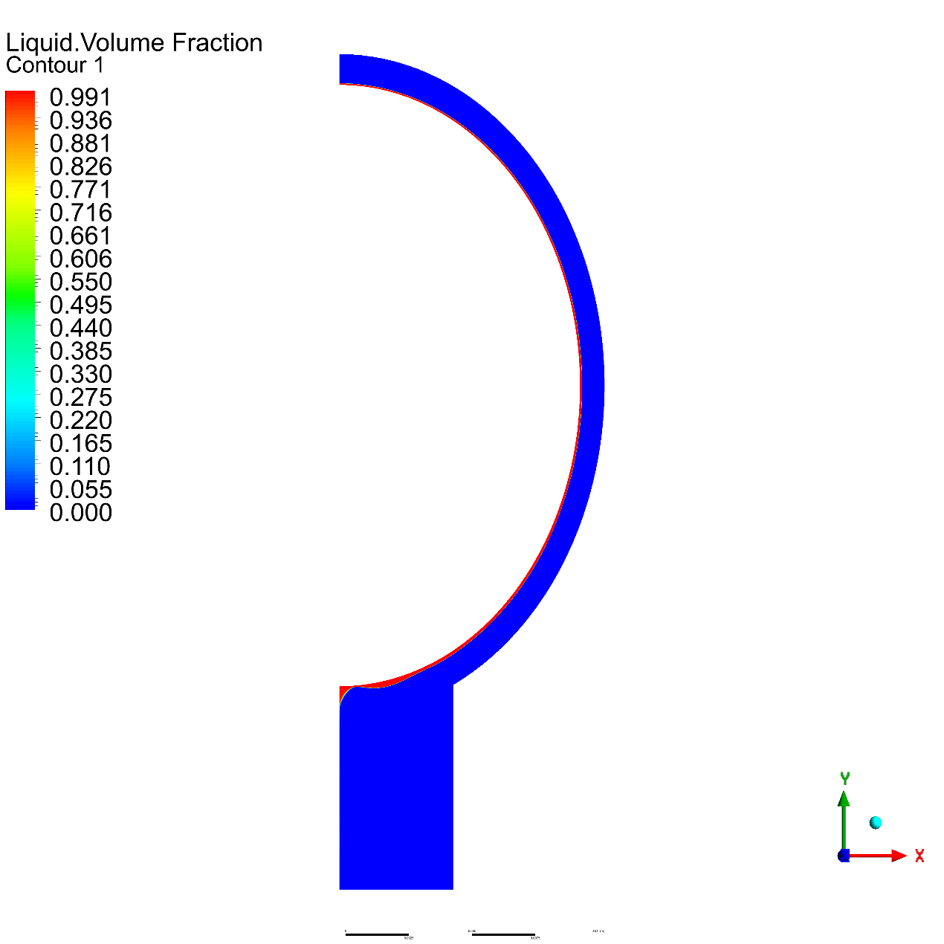

E = 0.6

Temperature

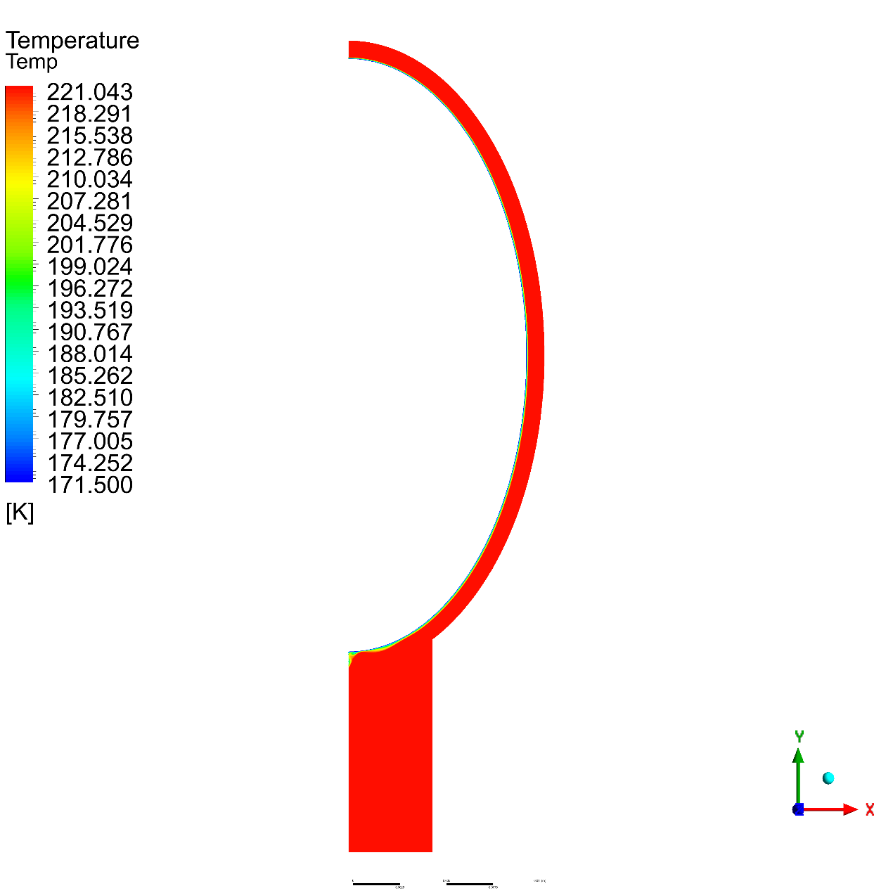

Volume Fraction

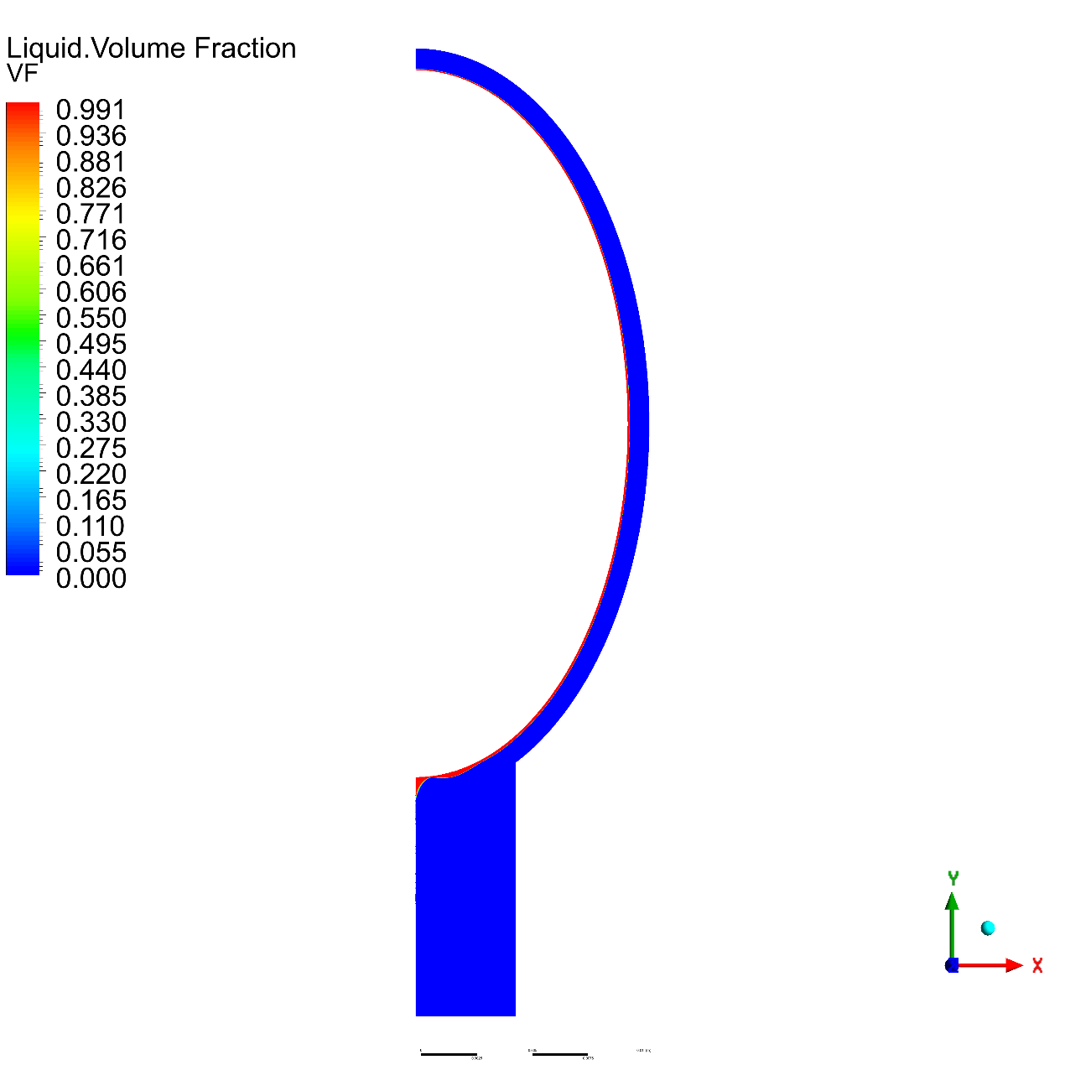

E = 0.4

Temperature

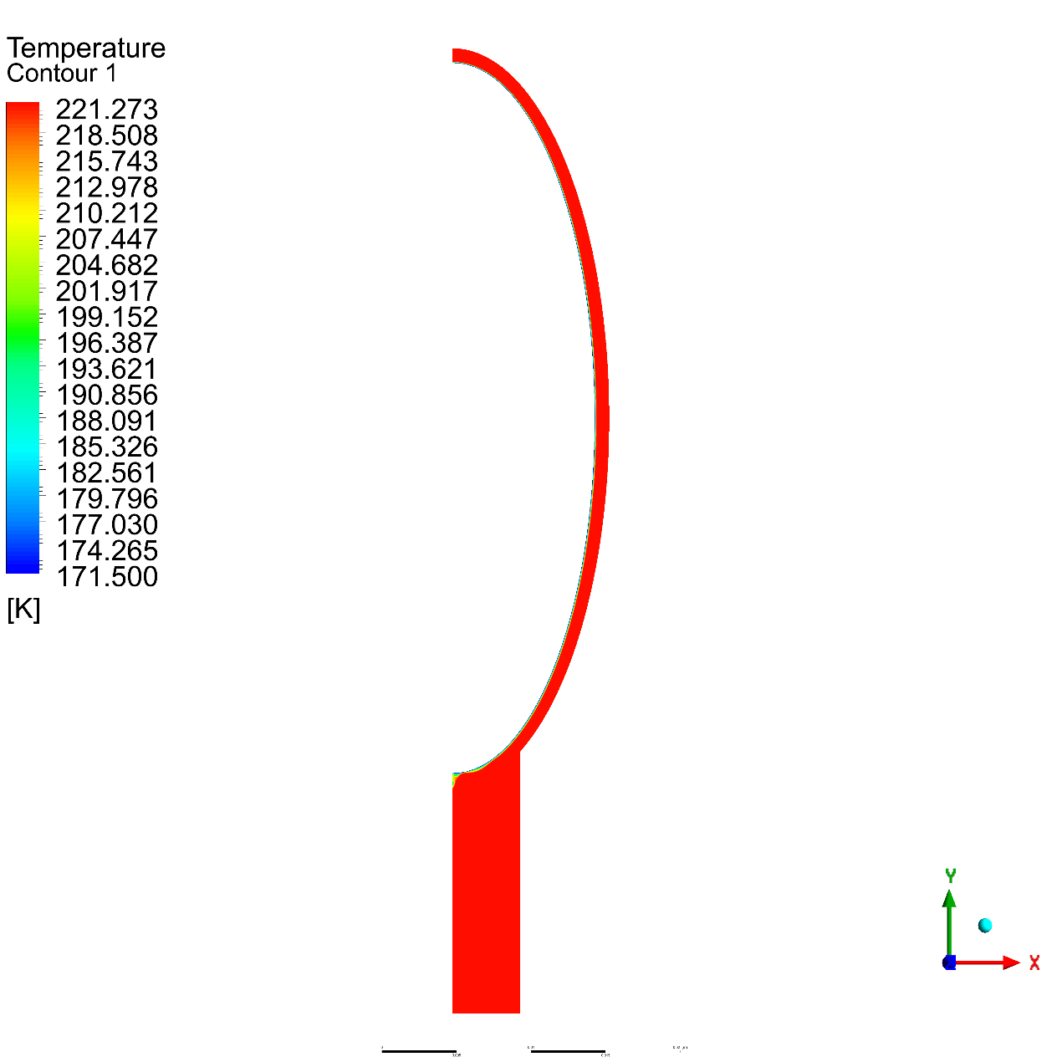

Volume Fraction

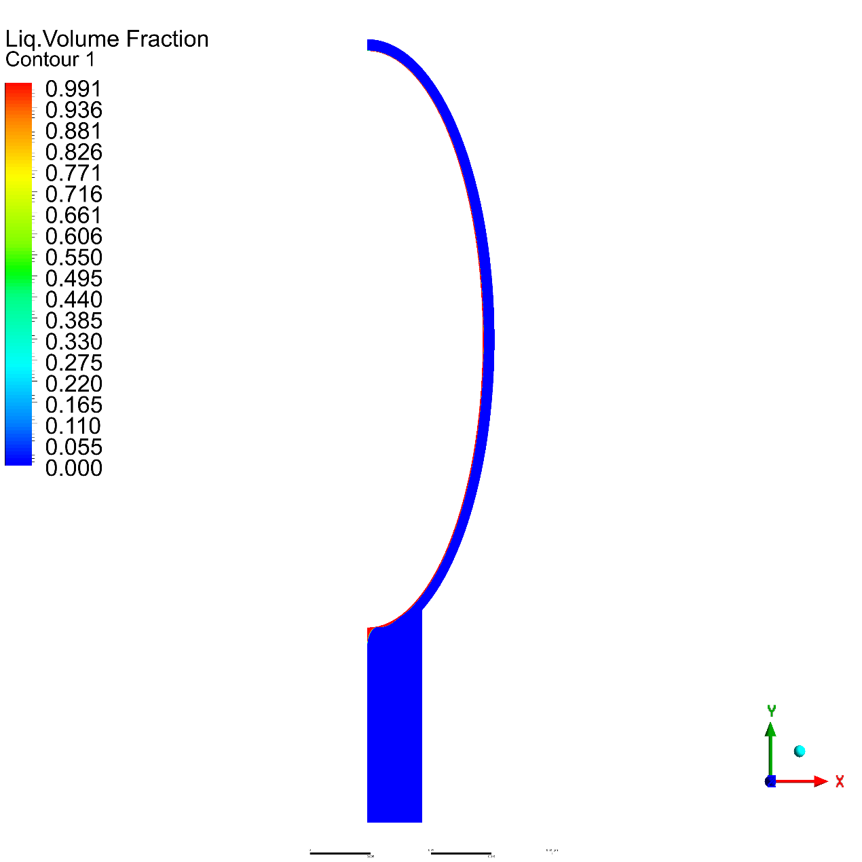

E = 0.2

Temperature

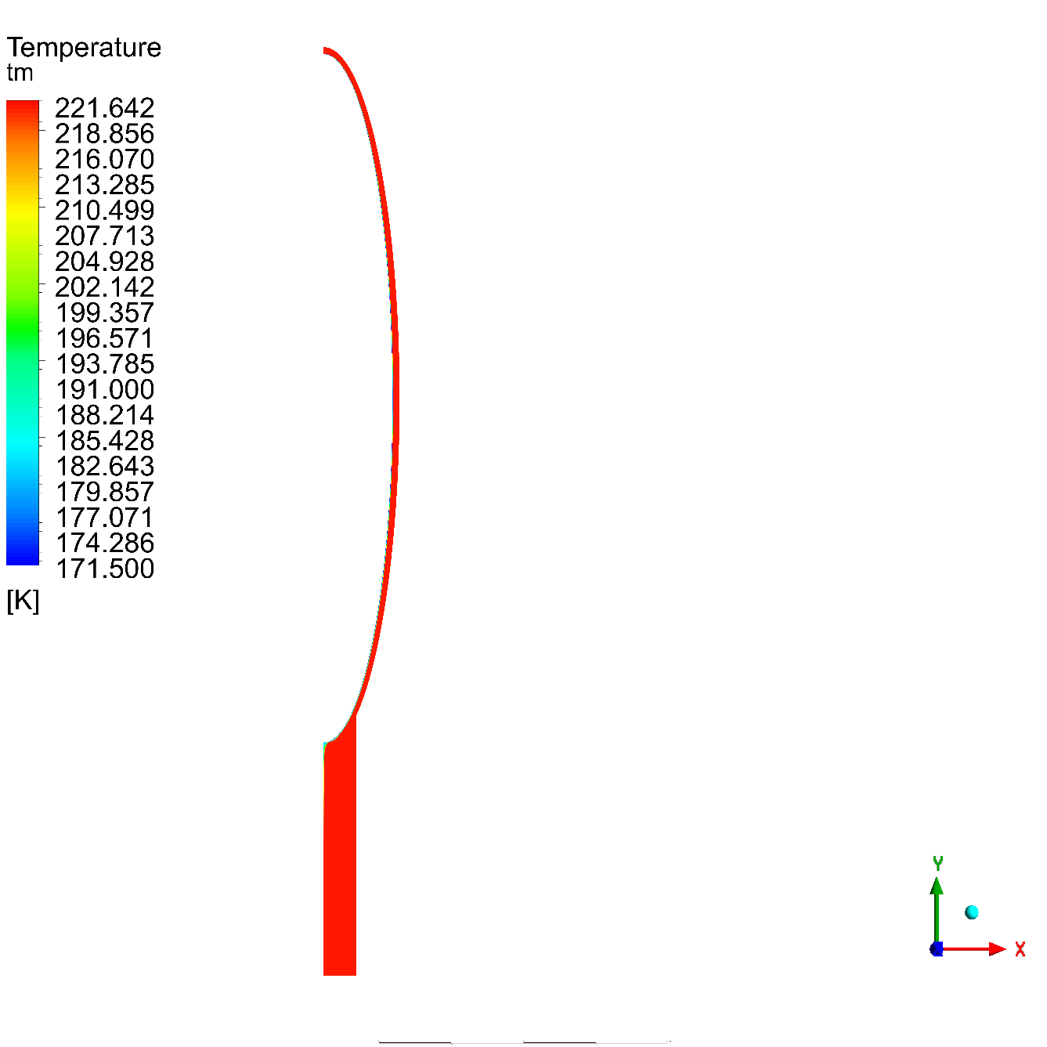

Volume Fraction

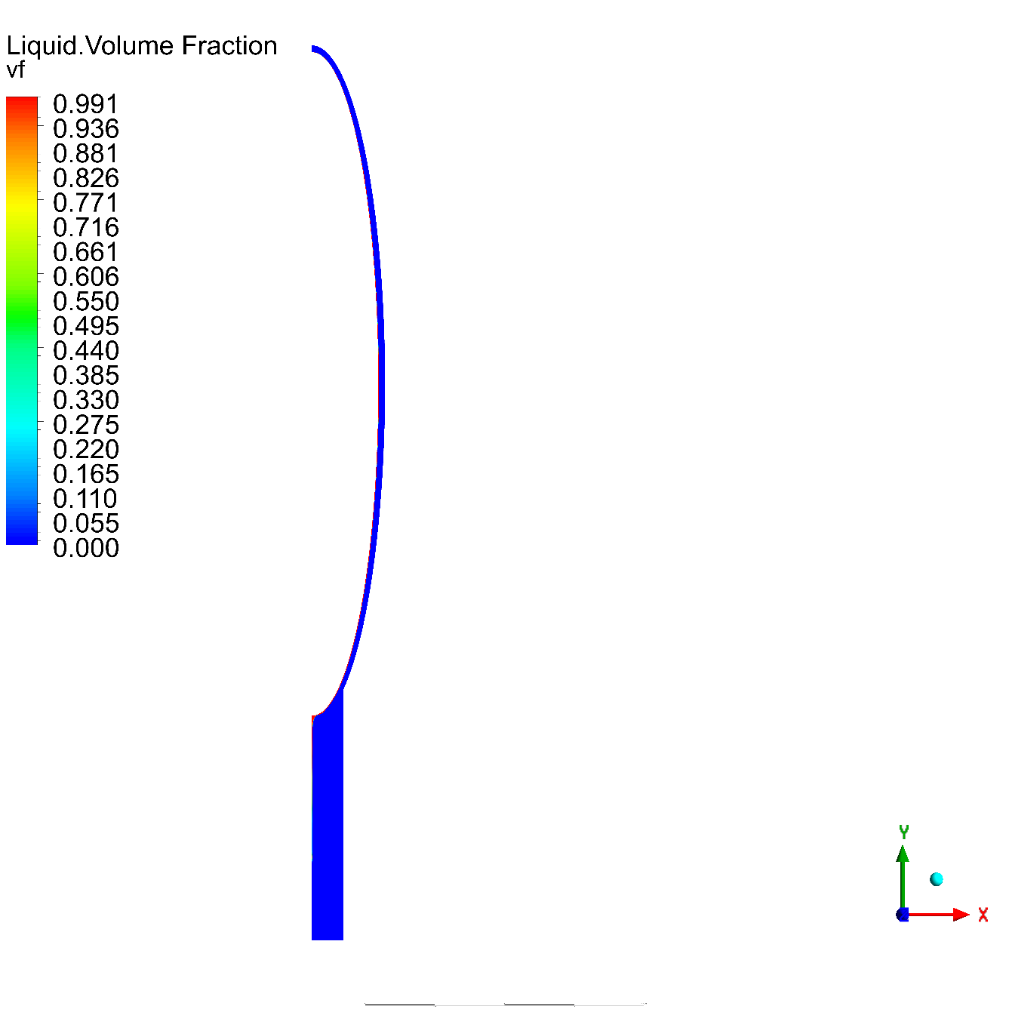

#### R134a (TM)

|  |  |  |  |
| --- | --- | --- | --- |
| Property | R134-a Liquid | R134-a Vapor | Unit |
| Density | $$1309$$ | 5.25 | $$kg/m^{3}$$ |
| Dynamic Viscosity | 0.000249 | 1.13e-05 | kg/ (m s) |
| Molecular weight | 102.03 | 102.03 | $$kg/kmol$$ |
| Specific heat | 1420 | 880 | $$j/(kgk)$$ |
| Standard state enthalpy | 3.916e+08 | -2.845e+08 | $$J/kgmol$$ |
| Thermal conductivity | 0.081 | 0.013 | $$W/(mk)$$ |

E = 0.8

Temperature

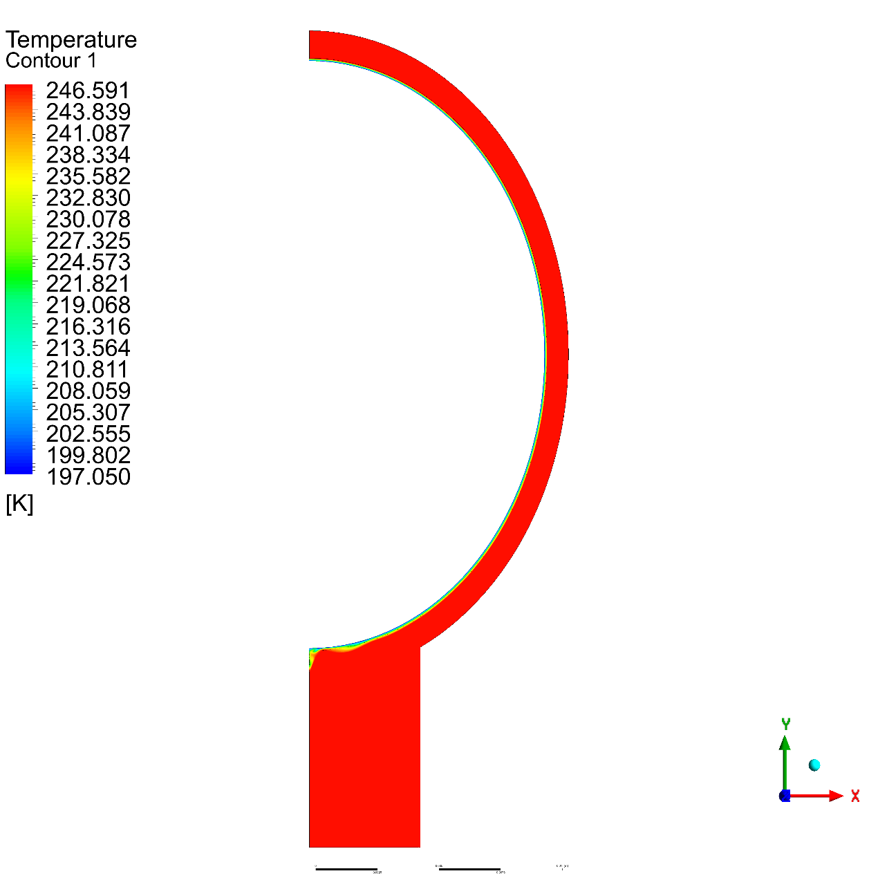

Volume Fraction

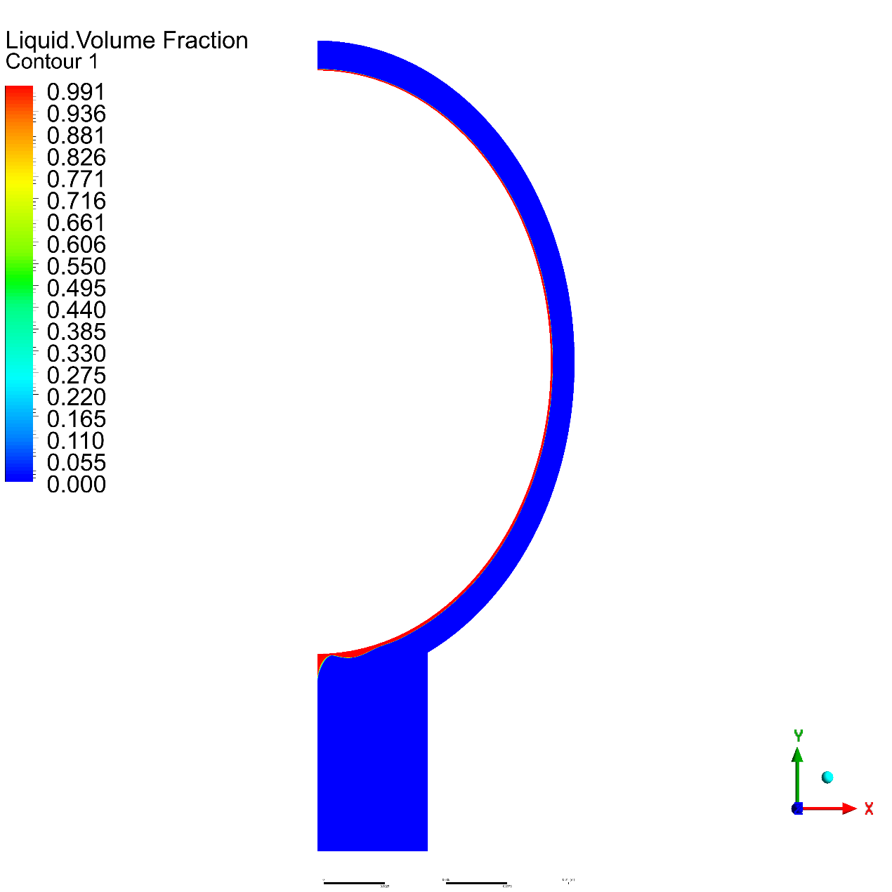

E = 0.6

Temperature

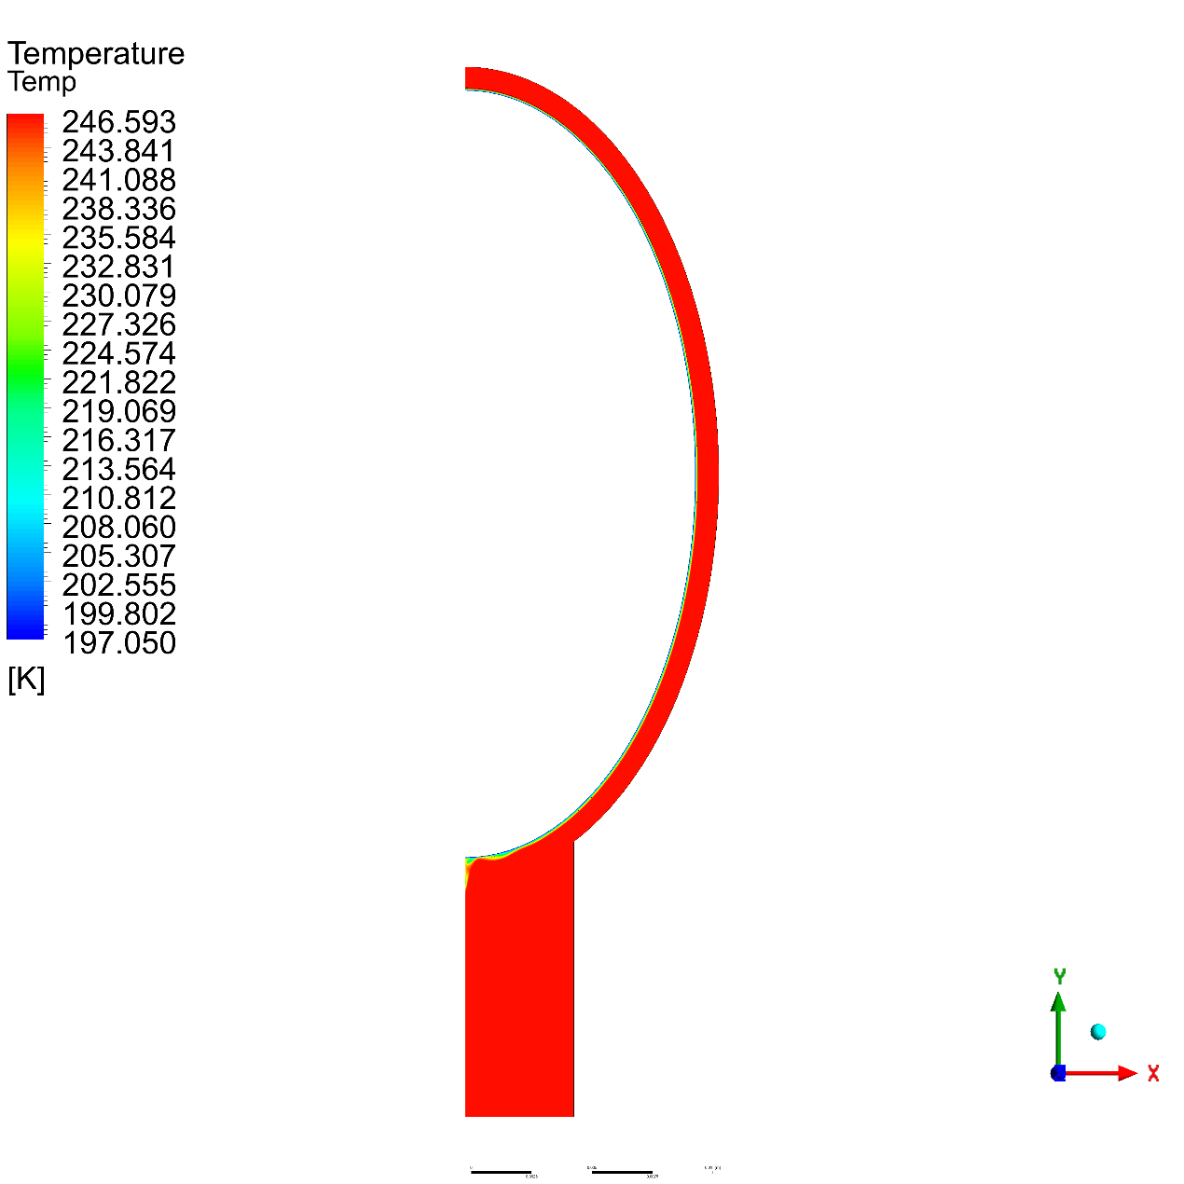

Volume Fraction

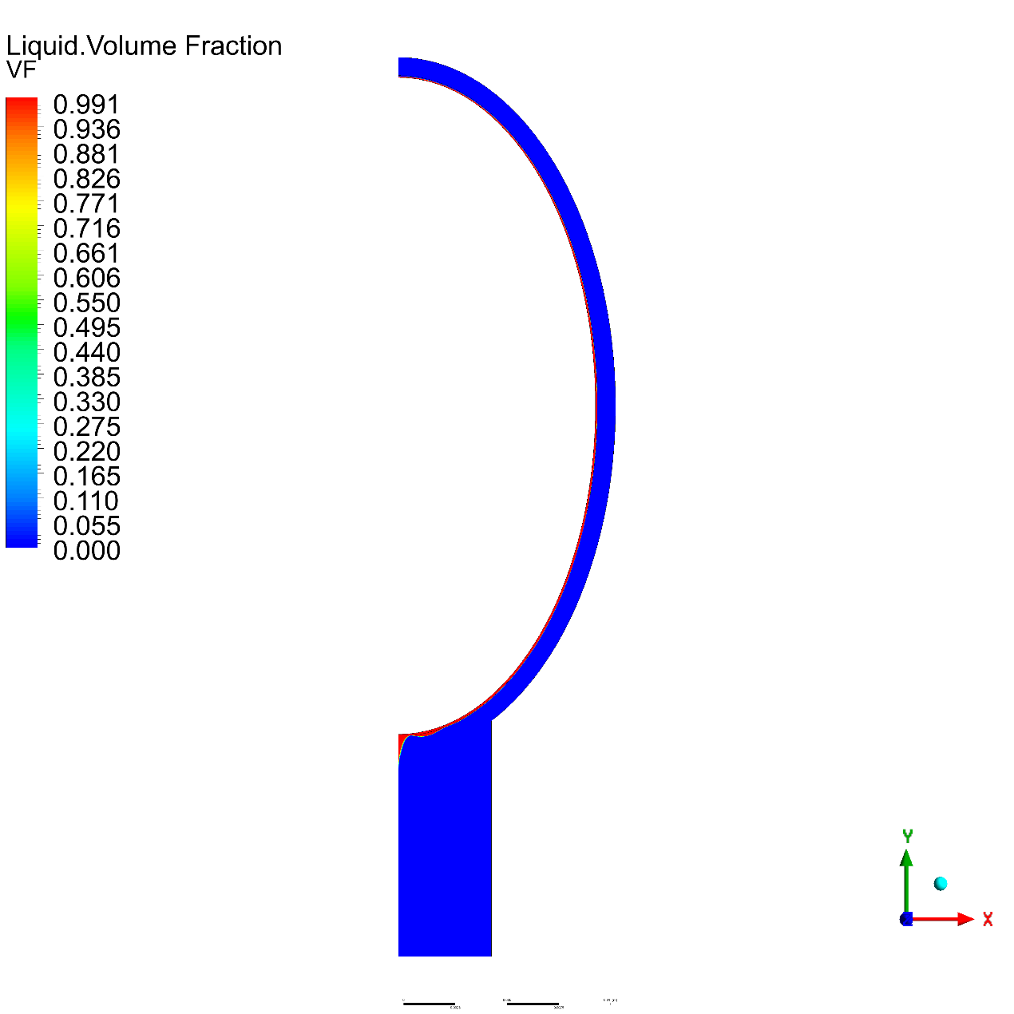

E = 0.4

Temperature

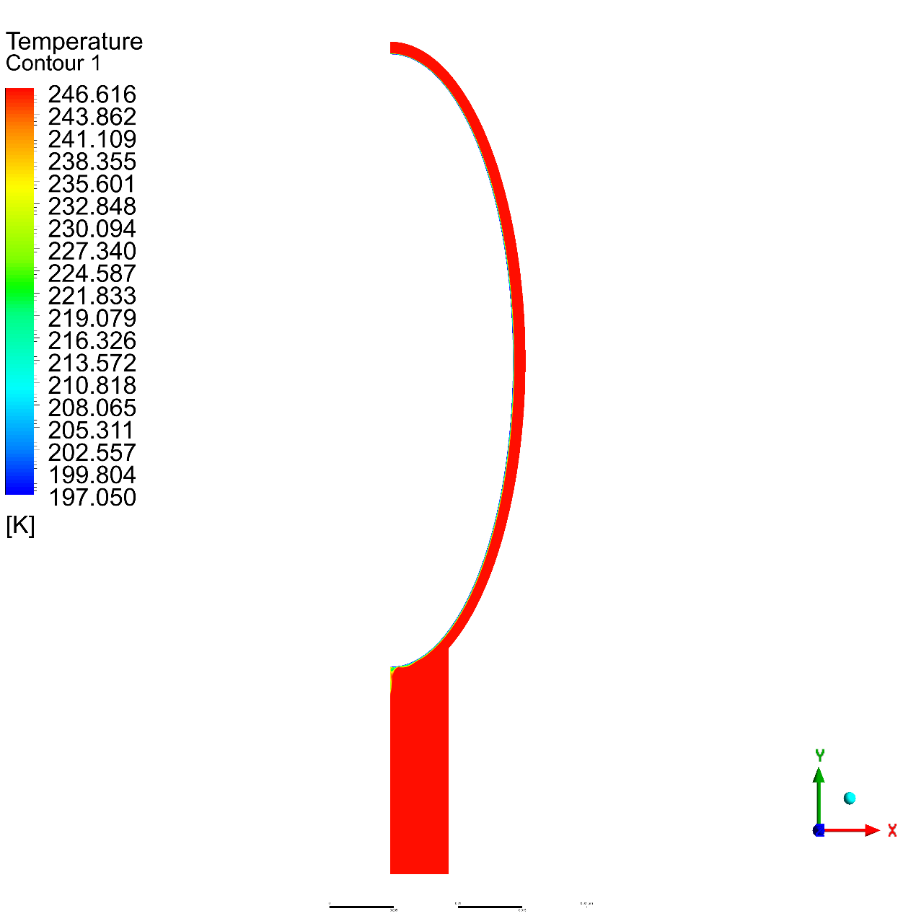

Volume Fraction

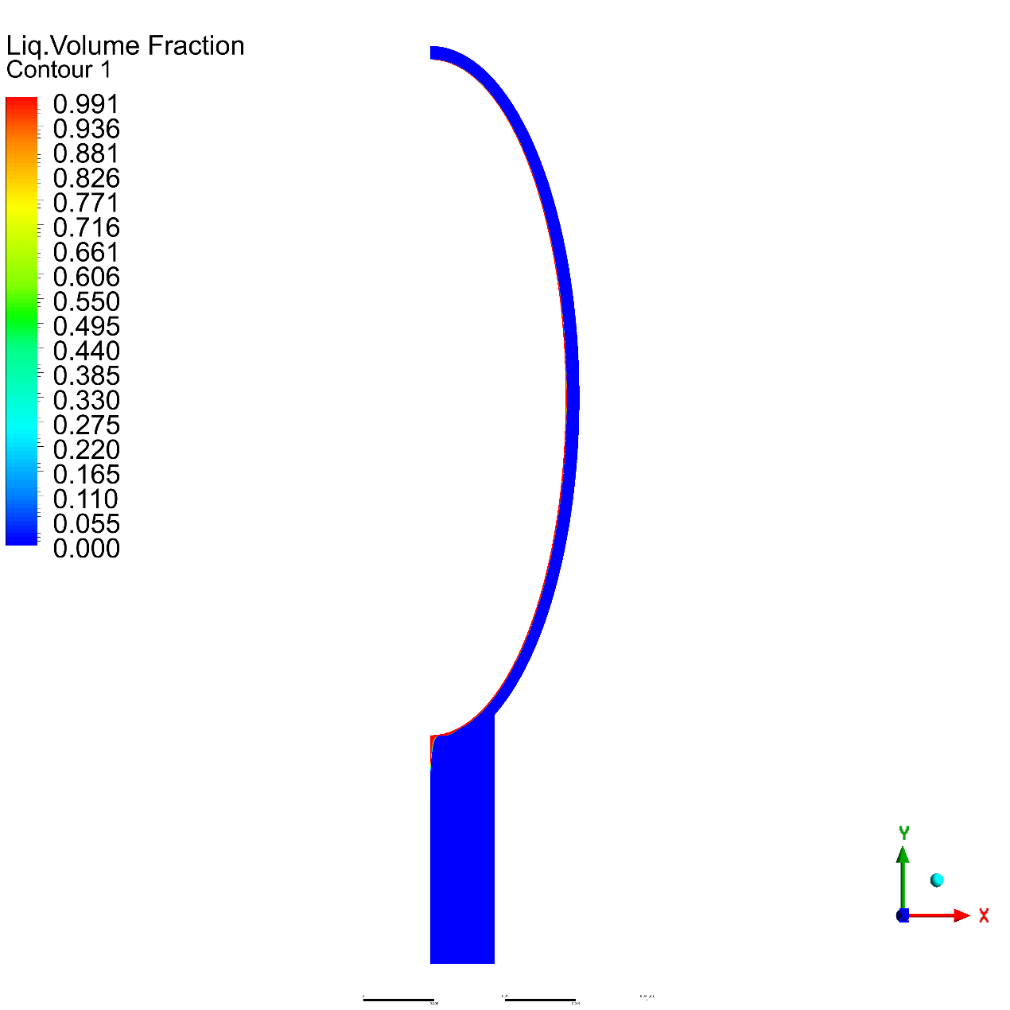

E = 0.2

Temperature

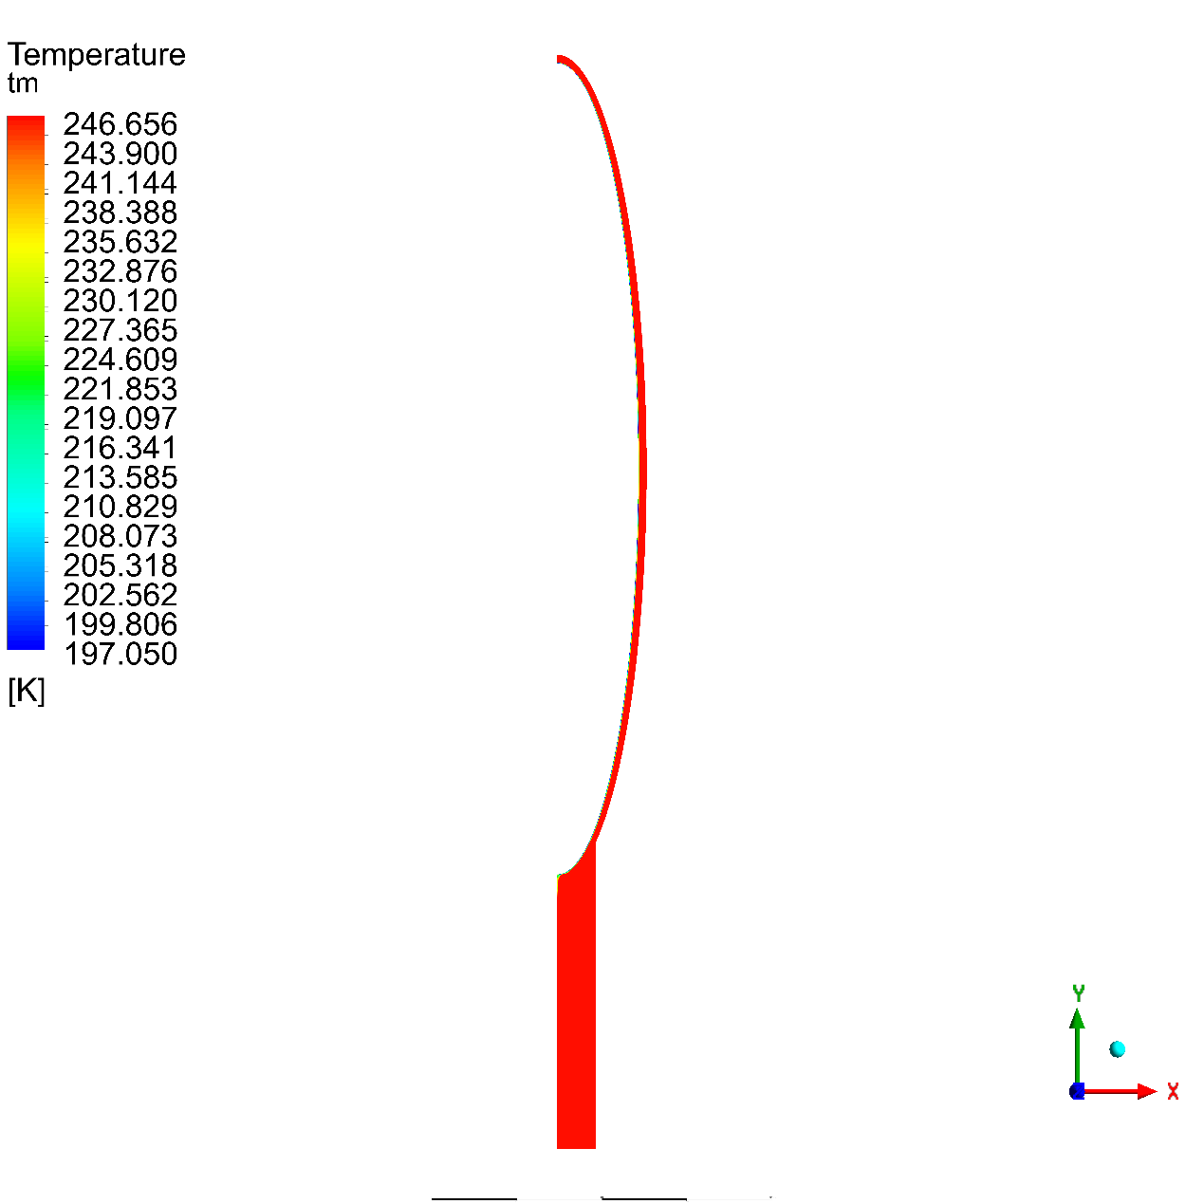

Volume Fraction

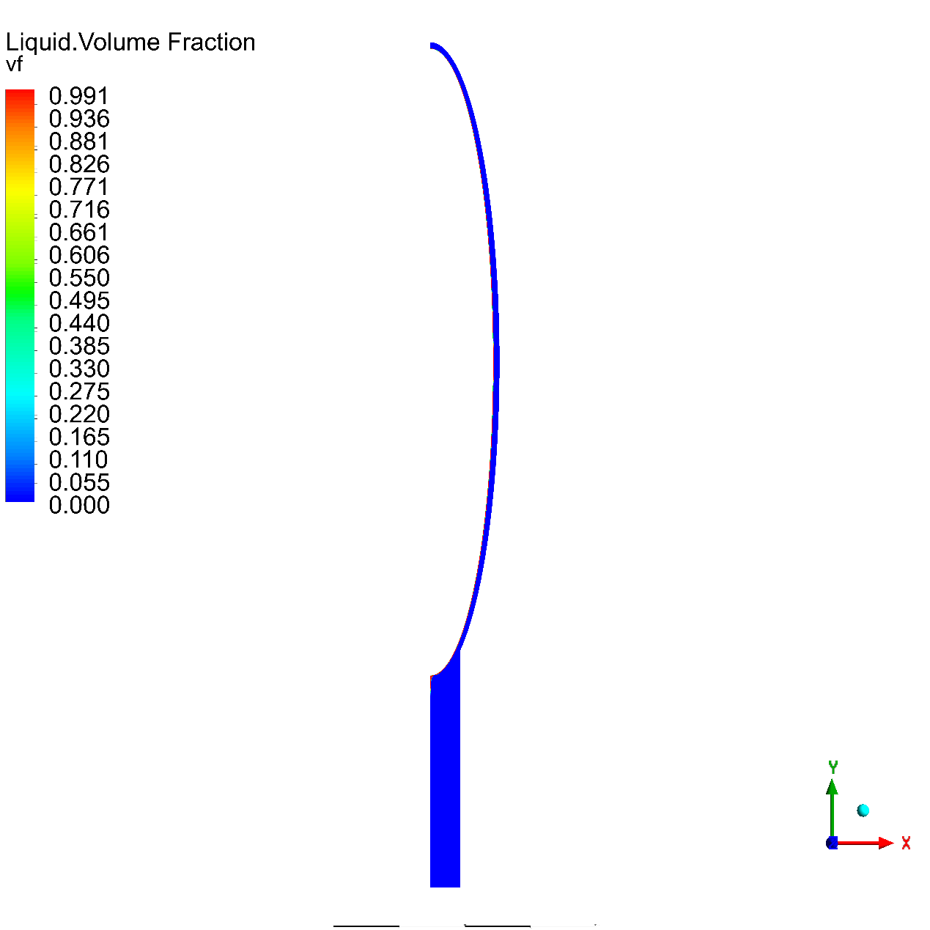

#### R410-a Material (Freon, n.d.)

|  |  |  |  |
| --- | --- | --- | --- |
| Property | R410-a Liquid | R410-a Vapor | Unit |
| Density | 1415 | 5.11 | $$kg/m^{3}$$ |
| Dynamic Viscosity | 0.000348 | 1.23e-05 | kg/ (m s) |
| Molecular weight | 72.6 | 72.6 | $$kg/kmol$$ |
| Specific heat | 1580 | 870 | $$j/(kgk)$$ |
| Standard state enthalpy | -7.636e+08 | -7.053e+08 | $$J/kgmol$$ |
| Thermal conductivity | 0.093 | 0.0102 | $$W/(mk)$$ |

E = 0.8

Temperature

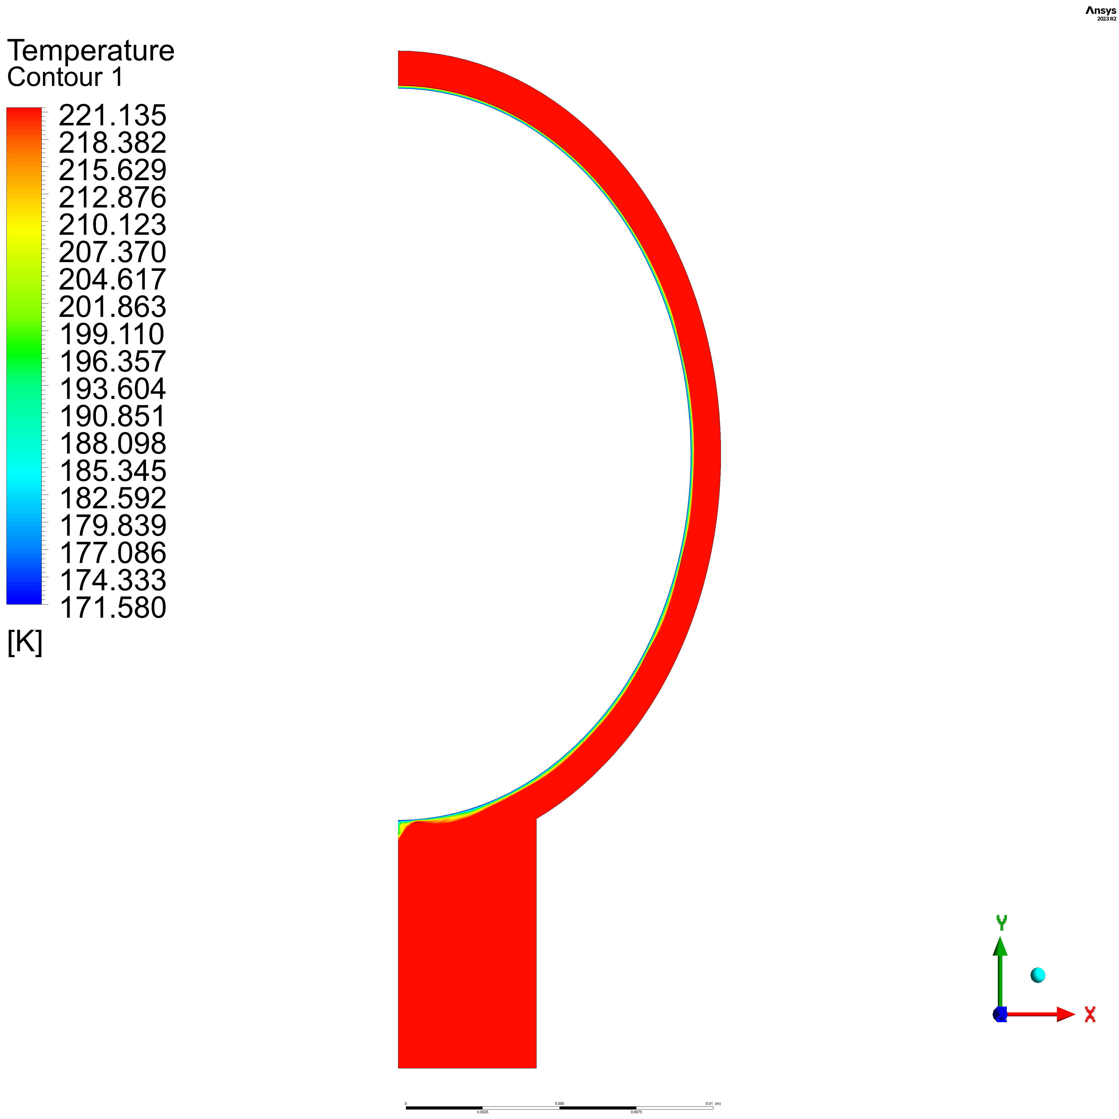

Volume Fraction

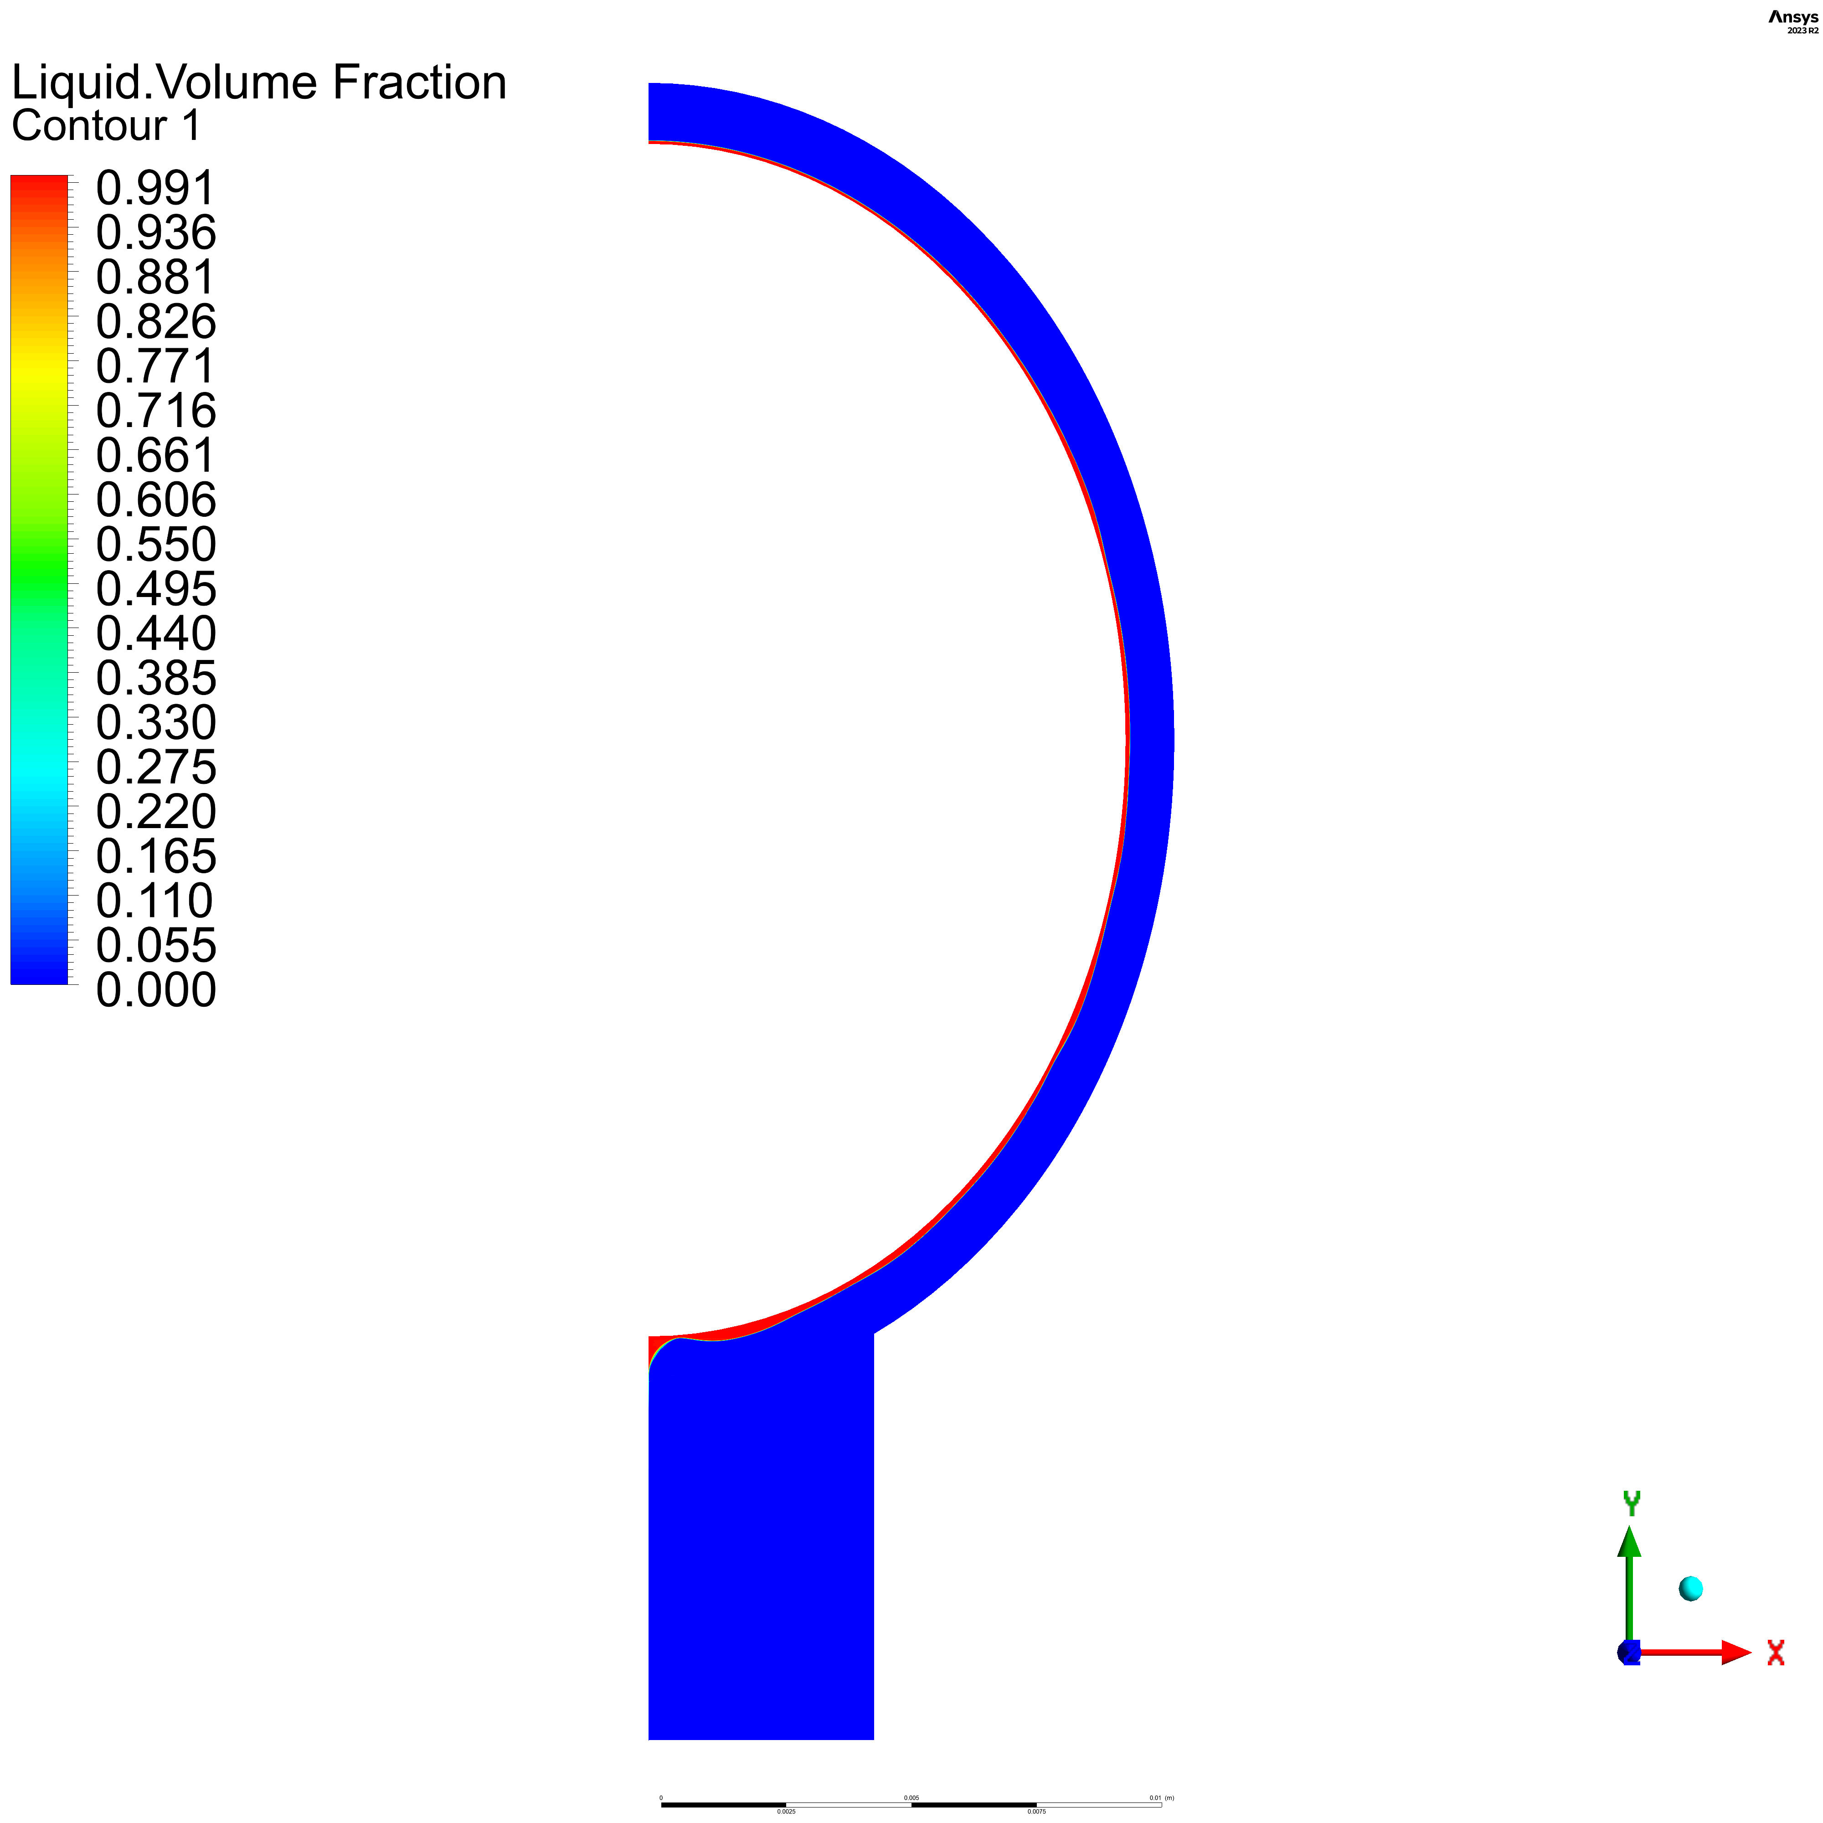

E = 0.6

Temperature

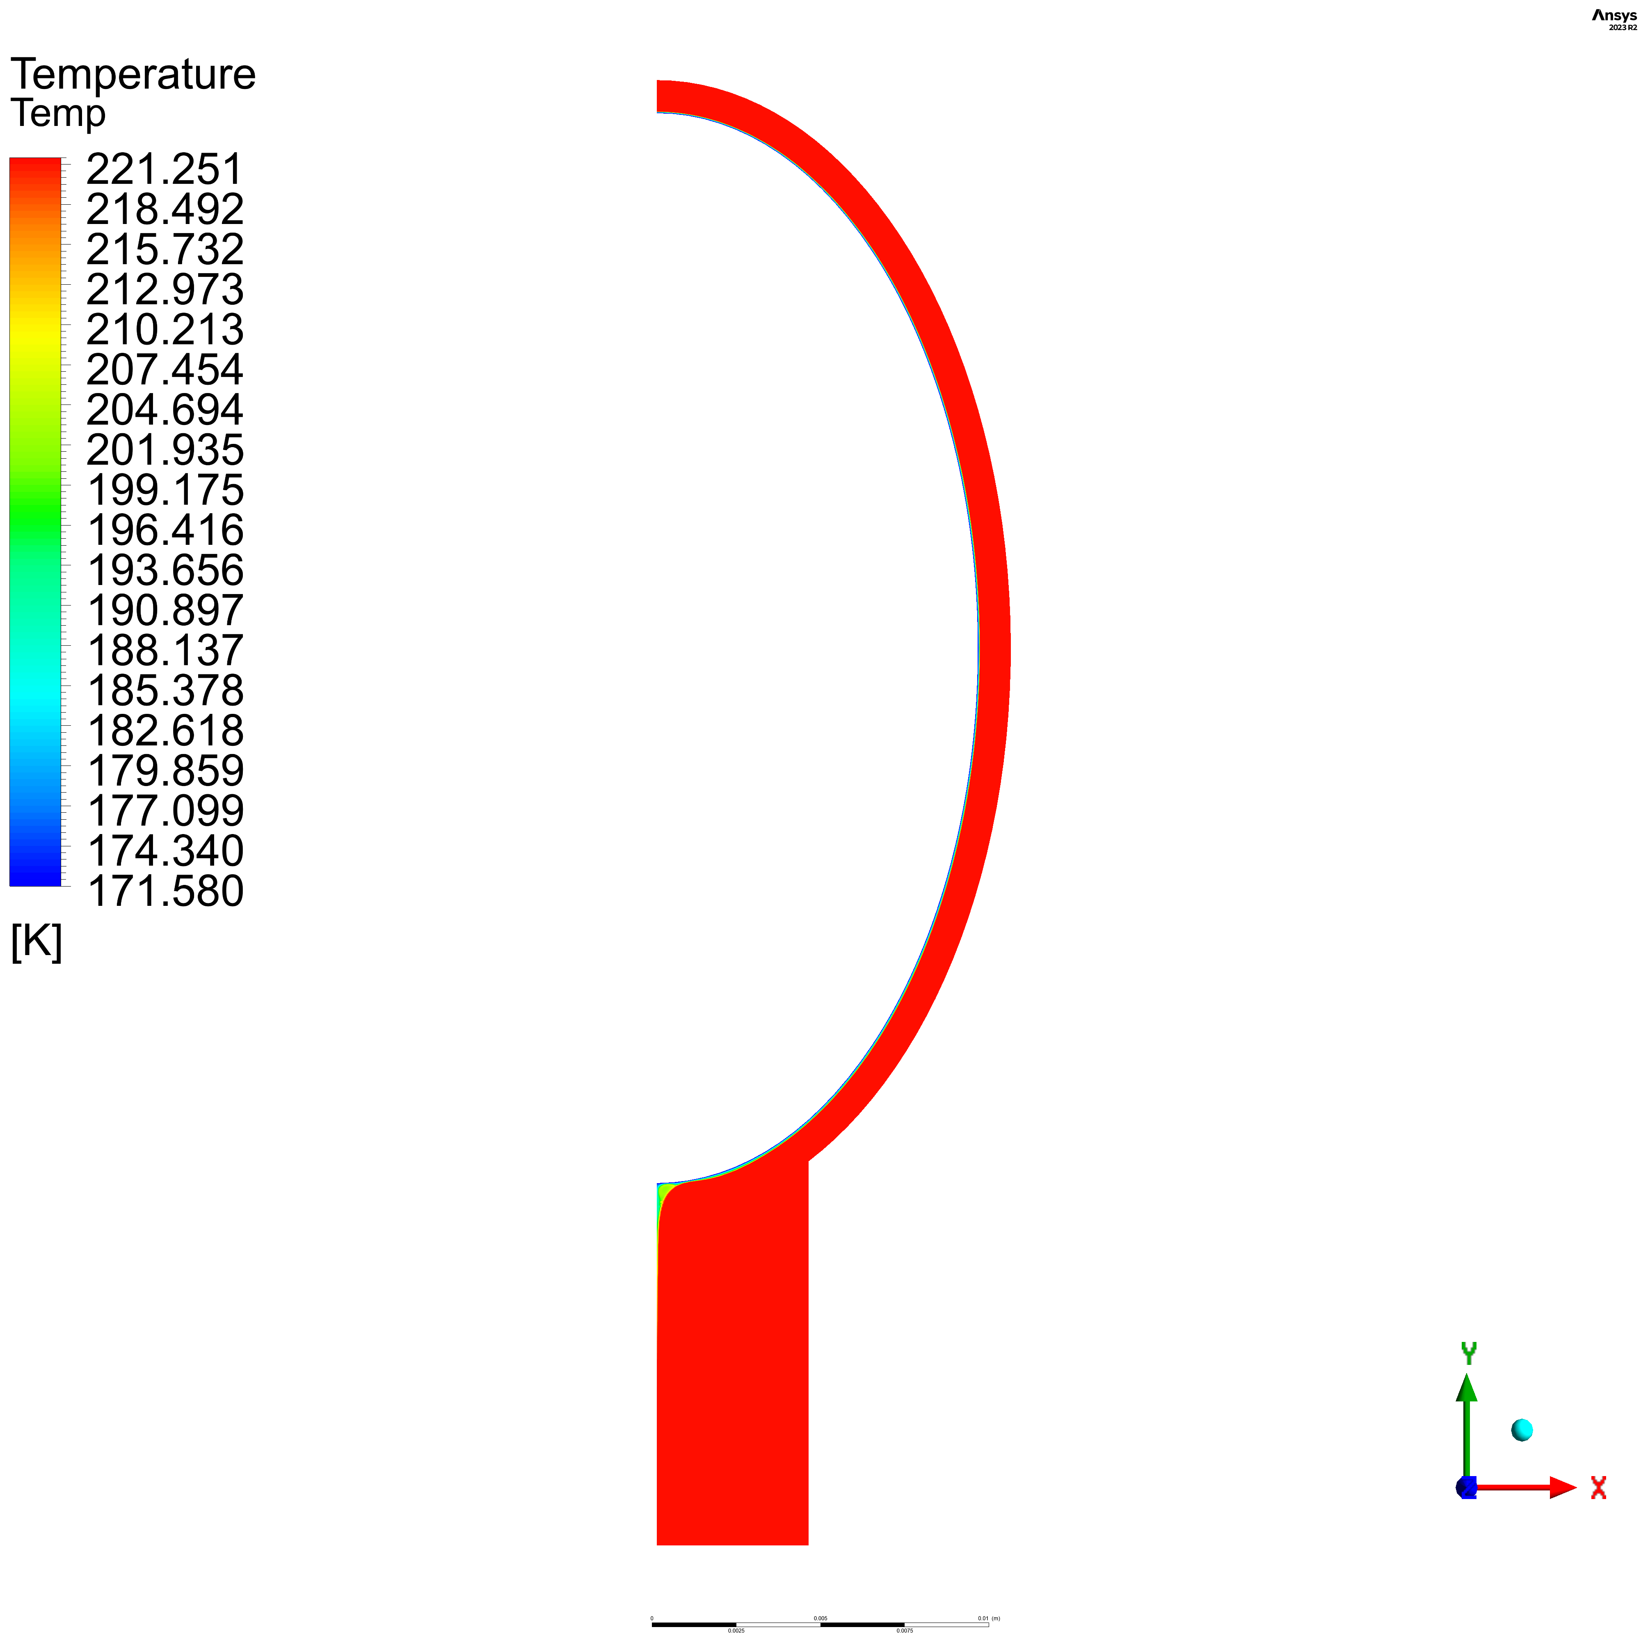

Volume Fraction

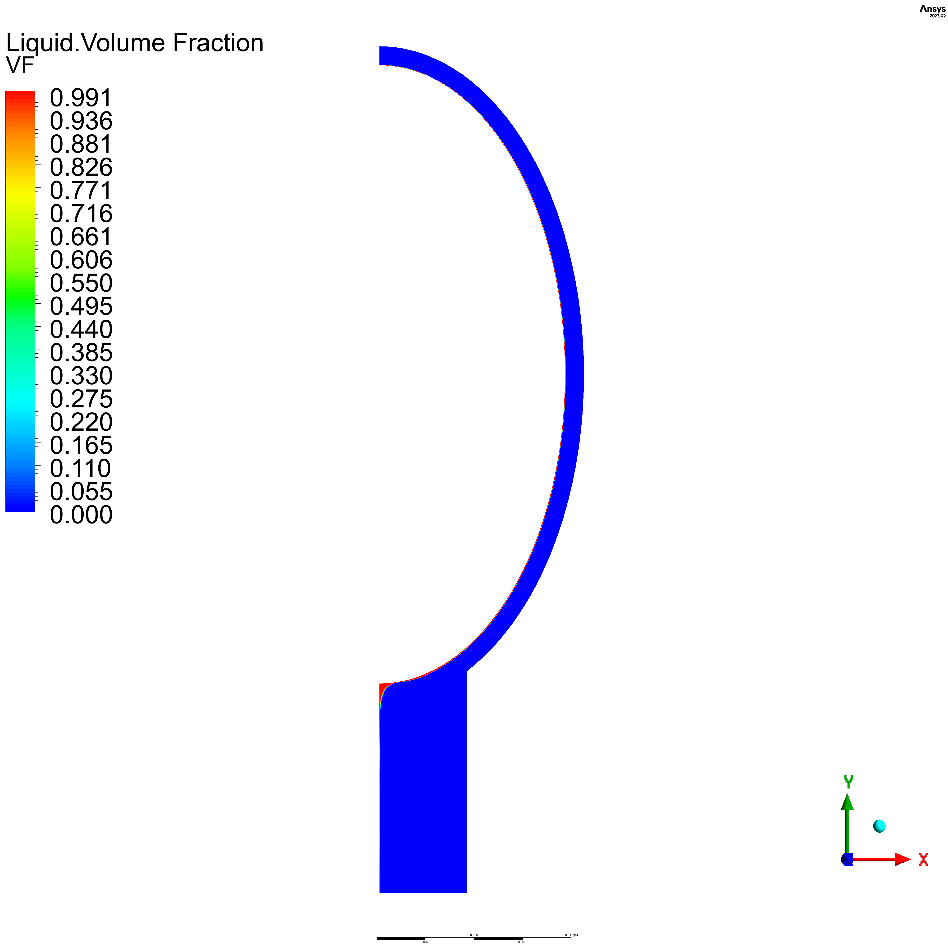

E = 0.4

Temperature

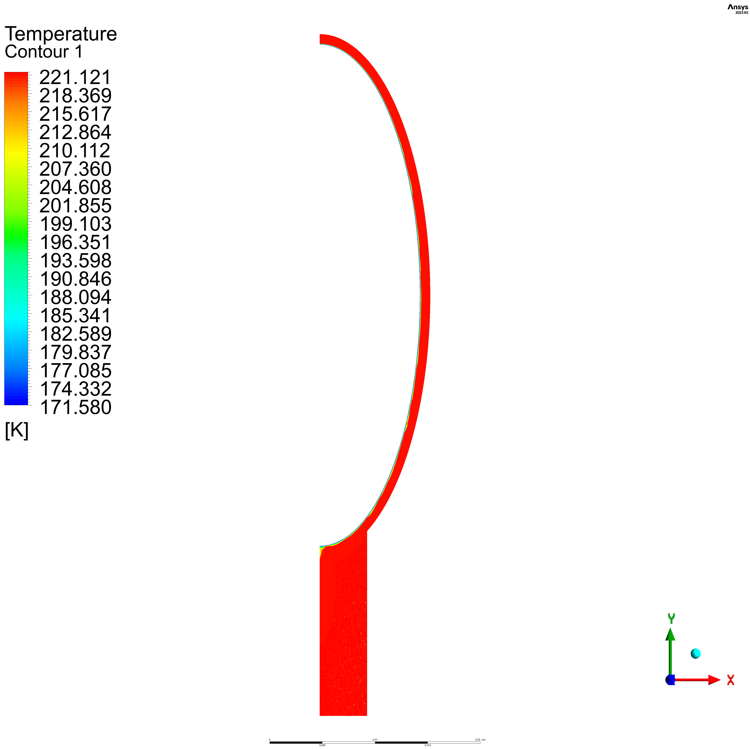

Volume Fraction

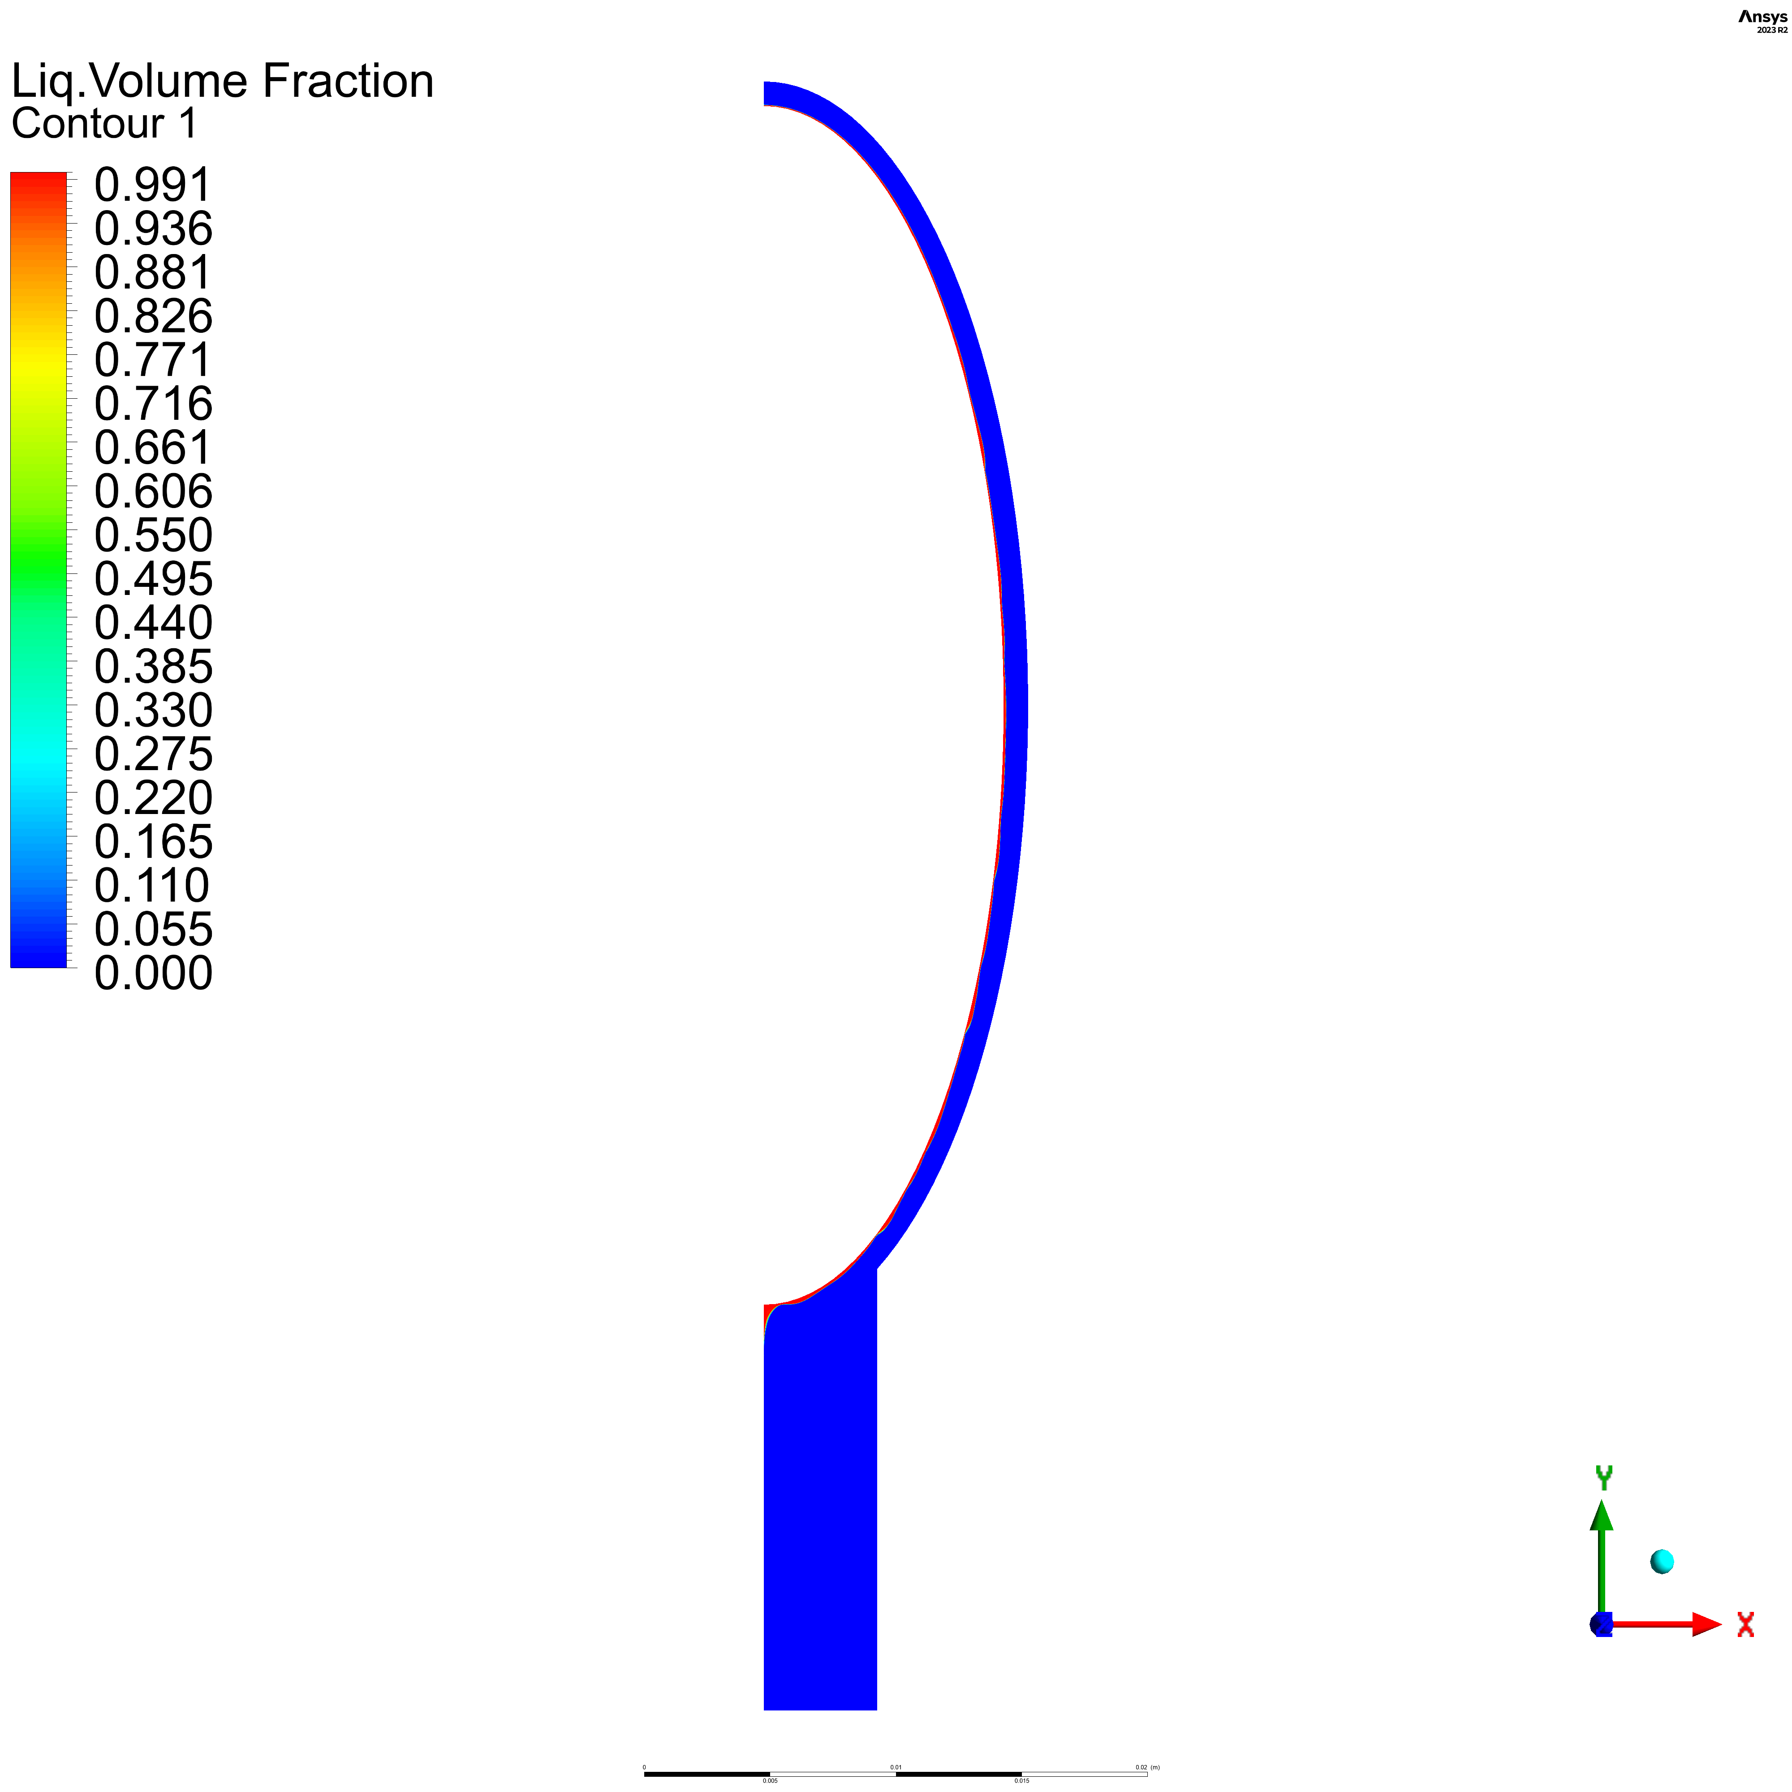

E = 0.2

Temperature

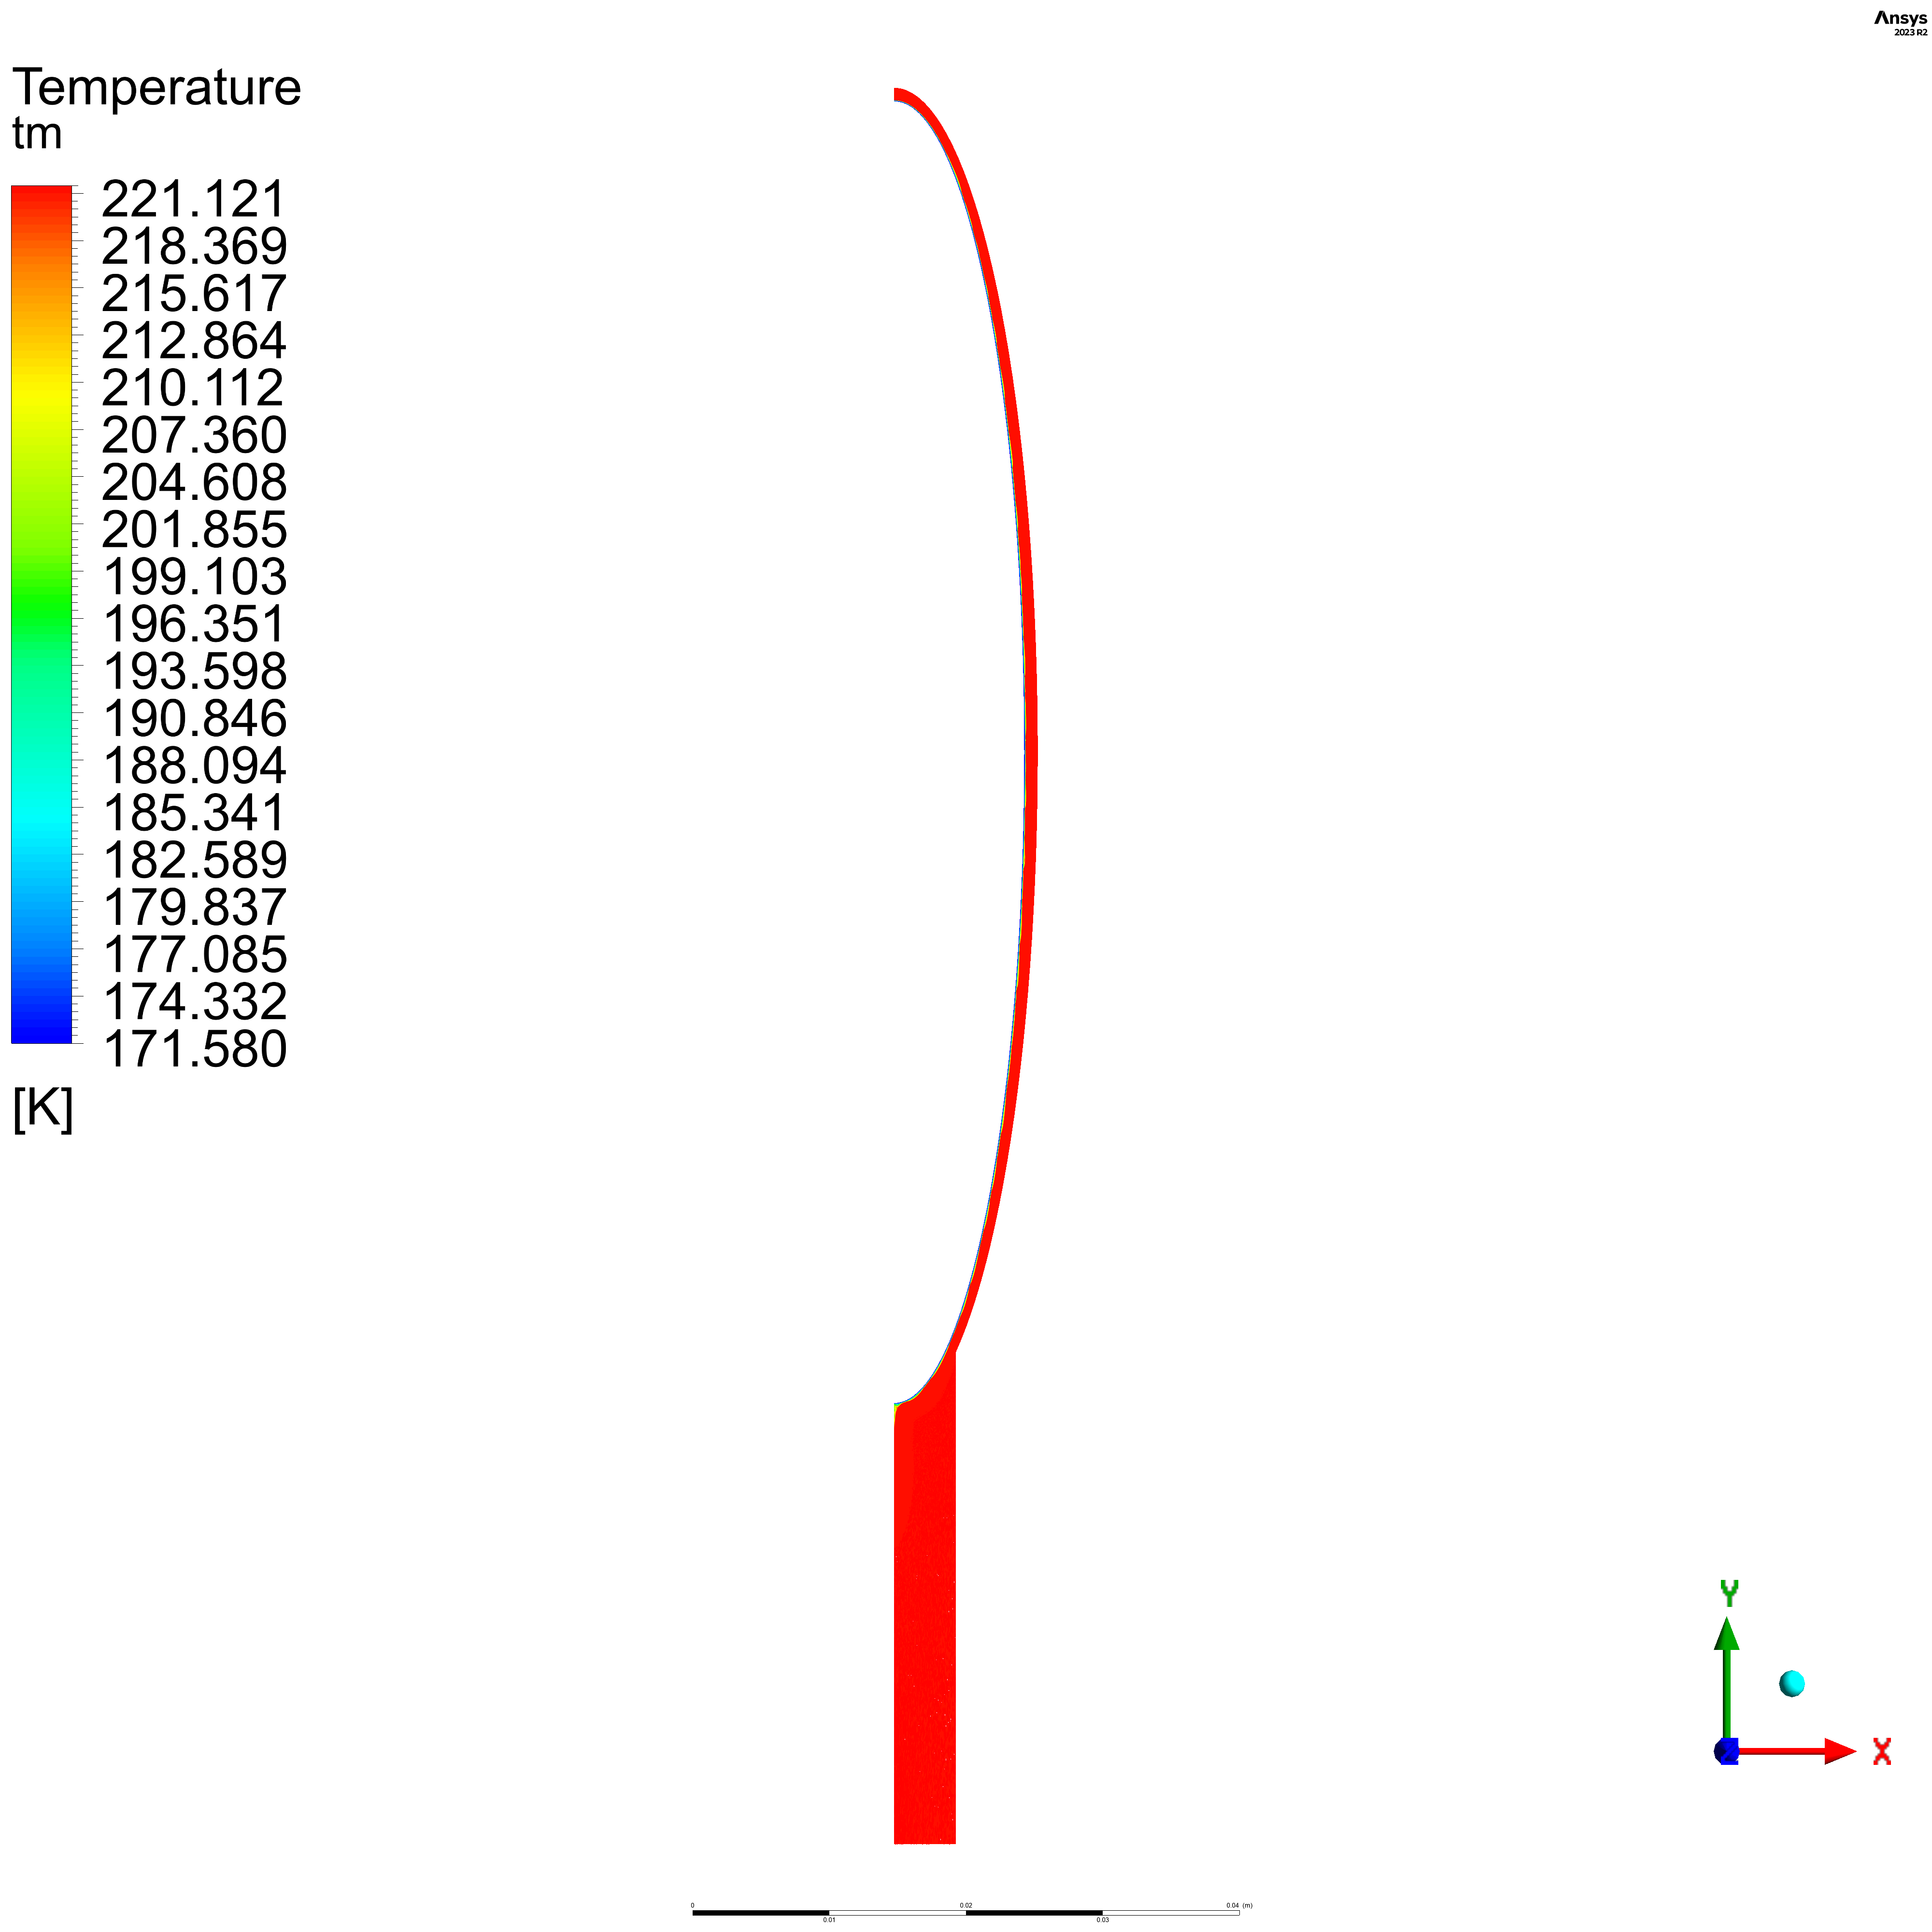

Volume Fraction

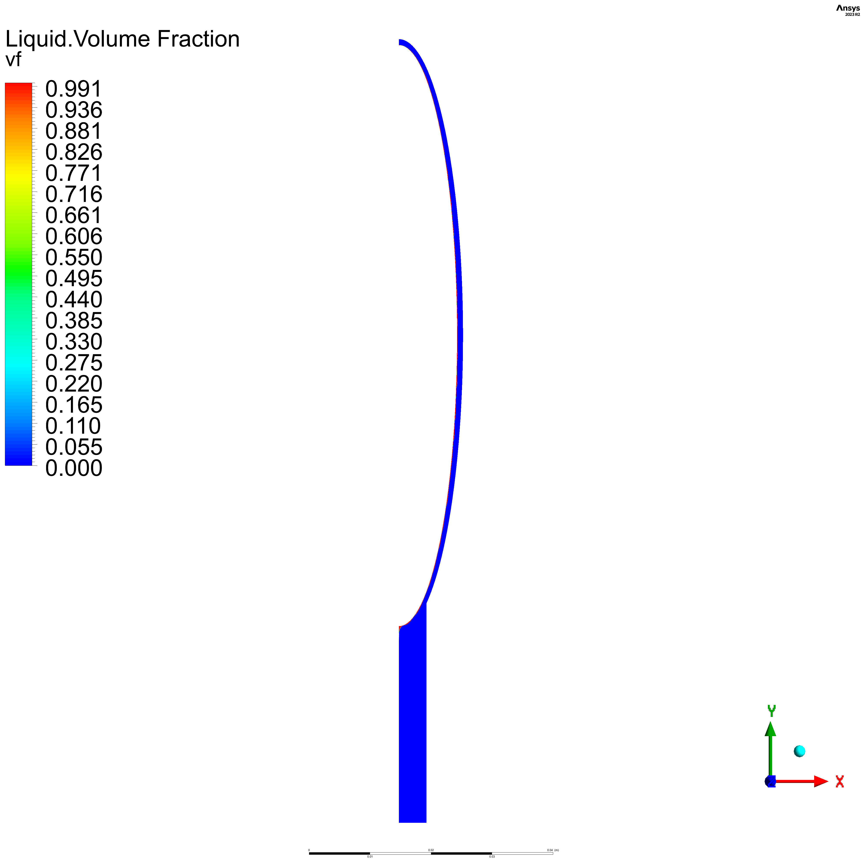

## 4. Results

Wall average heat flux coefficient

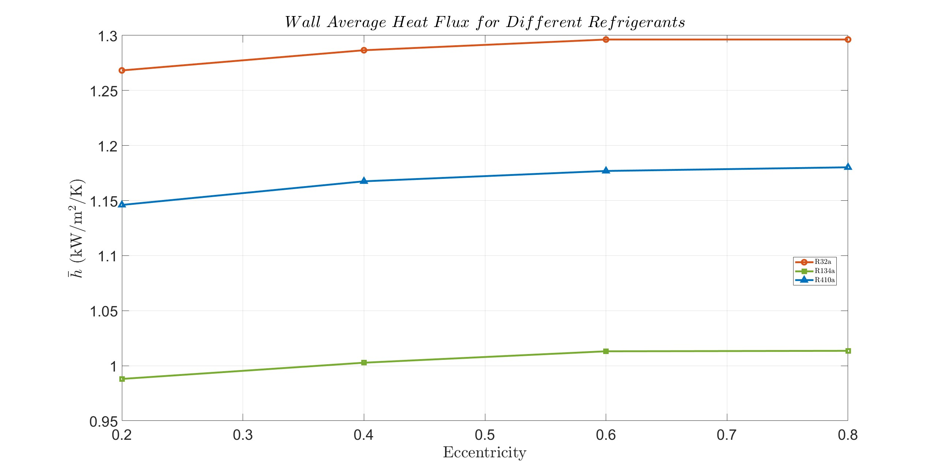

# References

ANSYS, I. (n.d.). Retrieved from enea: https://www.afs.enea.it/project/neptunius/docs/fluent/html/th/node297.htm

Kleiner, T. &. (2019). CFD model and simulation of pure substance condensation on horizontal tubes using the volume of fluid method. . *International Journal of Heat and Mass Transfer.*, 138. 420-431. 10.1016/j.ijheatmas.

Rattner, A. &. (2013). Simple Mechanistically Consistent Formulation for Volume-of-Fluid Based Computations of Condensing Flows. *Journal of Heat Transfer.*, 136. 10.1115/IMECE2013-63301.

Tian, J. &. (2020). Theoretical Study on Cryogen Spray Cooling in Laser Treatment of Ota’s Nevus: Comparison and Optimization of R134a, R404A and R32. *Energies.*, 13. 5647. 10.3390/en13215647.

TM, F. (n.d.). *Refrigerant (R-134a).*

toolbox, E. (n.d.). Retrieved from https://www.engineeringtoolbox.com/refrigerants-d_902.html

Yuan, Z. L. (2012). VOF MODELING AND ANALYSIS OF FILMWISE CONDENSATION BETWEEN VERTICAL PARALLEL PLATES. *Heat Transfer Research*, 47--68.

Zheng Liu, Z. Y. (2023). Evaluation of several liquid–vapor phase change models for numerical simulation of subcooled flow boiling. *Case Studies in Thermal Engineering*.